**JAVA SWING BASED – CAREER DENDROGRAM –**

# SQL CONNECTIVITY USING JDBC

*A Report*

*Submitted in partial fulfillment of the Requirements for the COURSE*

**DATABASE MANAGEMENT SYSTEMS**

**By**

**KUNCHAM ARJUN (1602-21-737-010)**

**Under the guidance of Ms B. Leelavathy**



**Department of Information Technology**

**Vasavi College of Engineering (Autonomous)**

**(Affiliated to Osmania University)**

**Ibrahimbagh, Hyderabad-31**

**2022-2023**

# BONAFIDE CERTIFICATE

This is to certify that this project report titled

## *‘CAREER DENDROGRAM’*

is a project work of **KUNCHAM ARJUN** bearing roll no. 1602-21-737-010 who carried out this project under my supervision in the IV semester for the academic year 2022- 2023

3

Signature Signature

External Examiner Internal Examiner

## ABSTRACT

Career Dendrogram is a console-based project that connects students looking for career choices with great skills and requirements. Every user, must enter their details and information required to generate the right career choice. The students can look out for jobs they are interested in. It allows the student to know what can be the best choice of career.

**Requirement Analysis**

**List of Tables:**

* User
* Question
* Quiz
* score

**List of Attributes with their Domain Types:**

**User**

|  |  |
| --- | --- |
| ● SID | NOT NULL VARCHAR2(15) |
| ● SNAME | NOT NULL VARCHAR2(20) |

**Quiz-table**

|  |  |
| --- | --- |
| Quiz id | VARCHAR2(15) |
| ● quiz name | VARCHAR2(10) |
| **Question table** |  |
| ● correct answer | VARCHAR2(15) |
| ● question_id | NOT NULL VARCHAR2(30) |
| ● quiz_id | NOT NULL VARCHAR2(30) |
|  |  |
|  |  |

**AIM AND PRIORITY OF THE PROJECT**

To create a **Java GUI-based** desktop application that connects students looking for career choices with skills and Interest. It takes values like student name, username, Age, Skills, etc through forms which are then updated in the database using JDBC connectivity.

## ARCHITECTURE AND TECHNOLOGY

**Software used:** Java, Oracle 11g Database, Java SE version 14, Run SQL.

**Java SWING:**

**Java SWING** is a GUI widget toolkit for Java. It is part of Oracle's Java Foundation Classes (JFC) - an API for providing a graphical user interface (GUI) for Java programs.

Swing was developed to provide a more sophisticated set of GUI components than the earlier AWT. Swing provides a look and feel that emulates the look and feel of several platforms, and also supports a pluggable look and feel that allows applications to have a look and feel unrelated to the underlying platform. It has more powerful and flexible components than AWT. In addition to familiar components such as buttons, check boxes and labels, Swing provides several advanced components such as tabbed panel, scroll panes, trees, tables, and lists.

**SQL:**

Structure Query Language(SQL) is a database query language used for storing and managing data in **Relational** DBMS. SQL was the first commercial language introduced for E.F Codd's Relational model of database. Today almost all RDBMS (MySql, Oracle, Infomix, Sybase, MS Access) use **SQL** as the standard database query language. SQL is used to perform all types of data operations in RDBMS.

### DESIGN

**Entity Relationship Diagram**

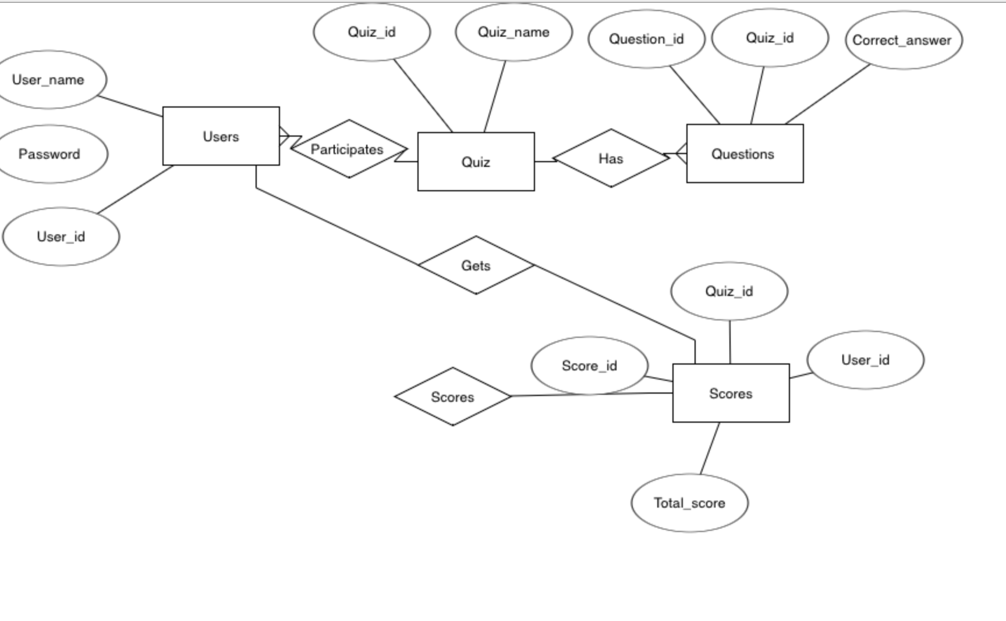

**TABLE CREATED IN SQL:**

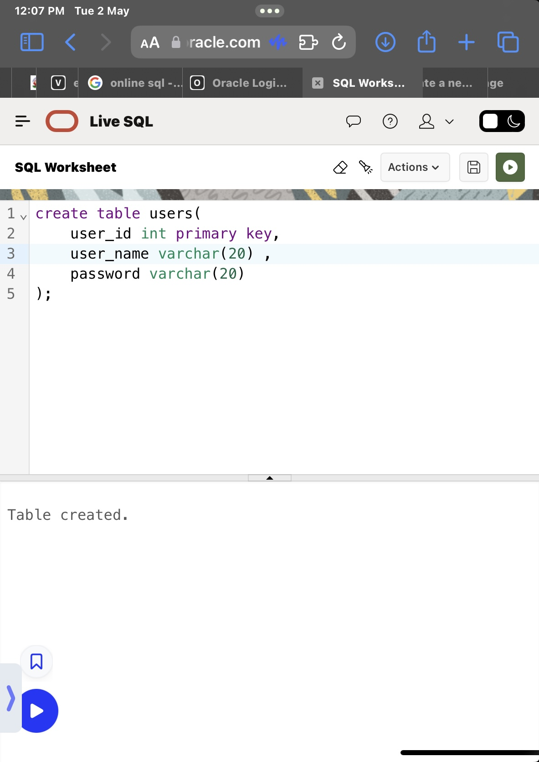1.User table

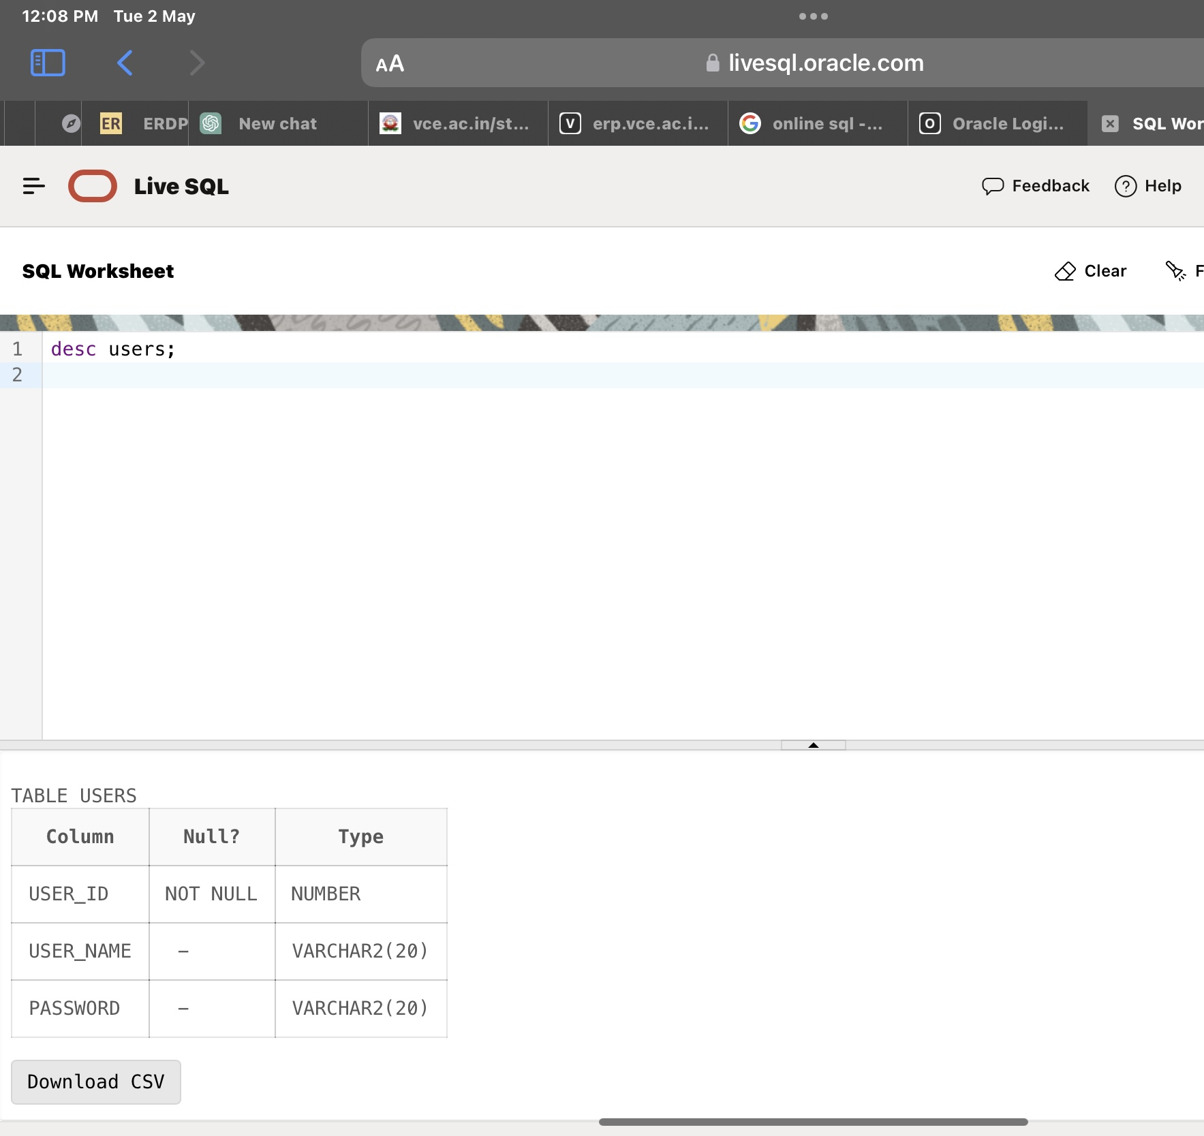

**2.Quiz table**

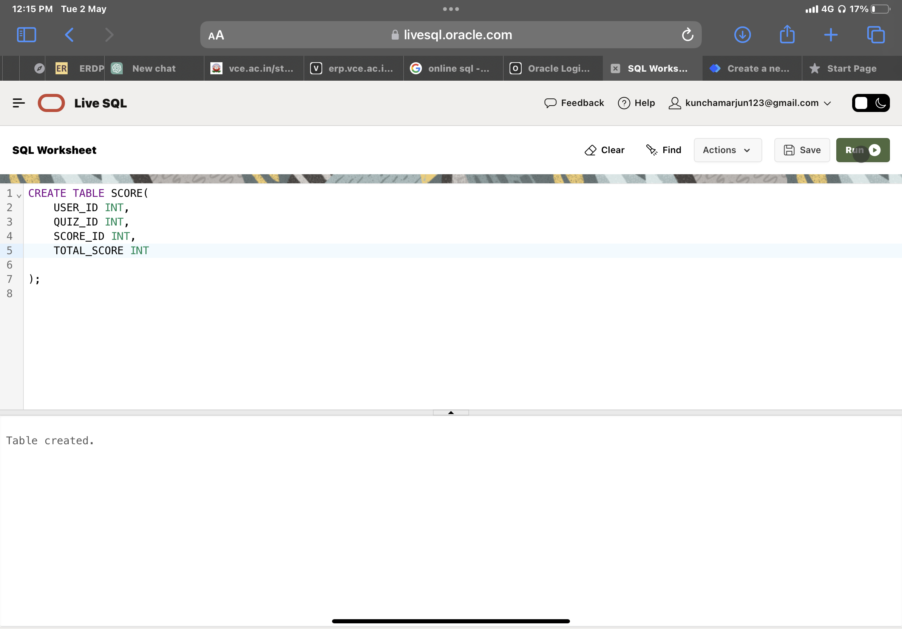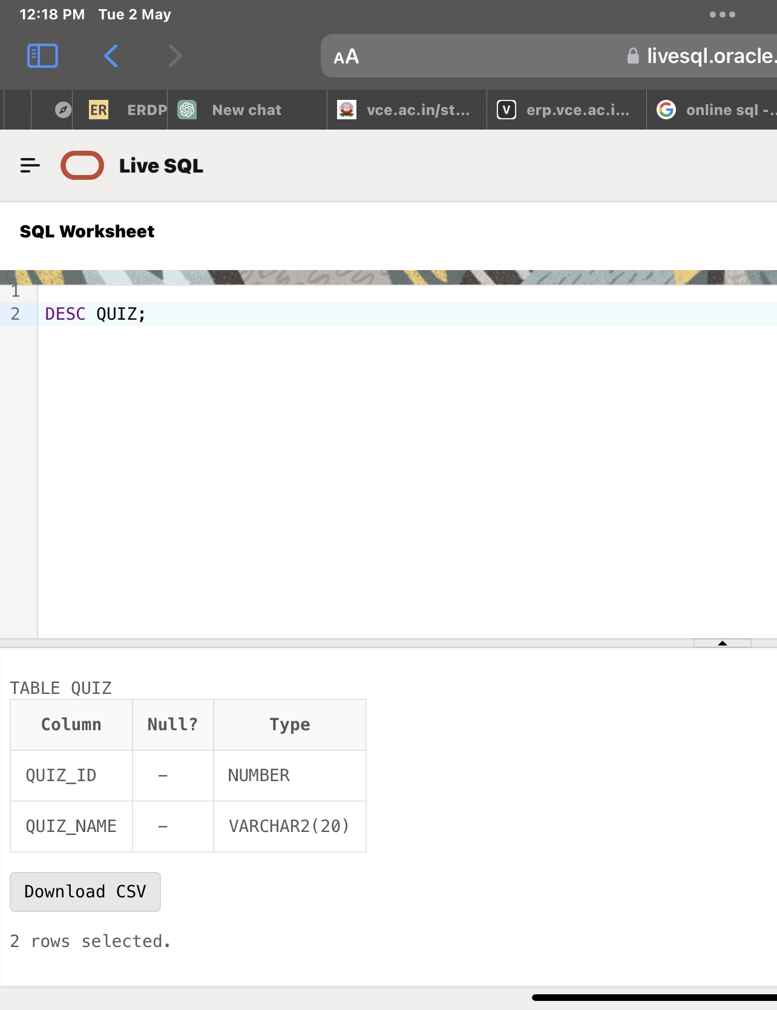

**3.Question table**

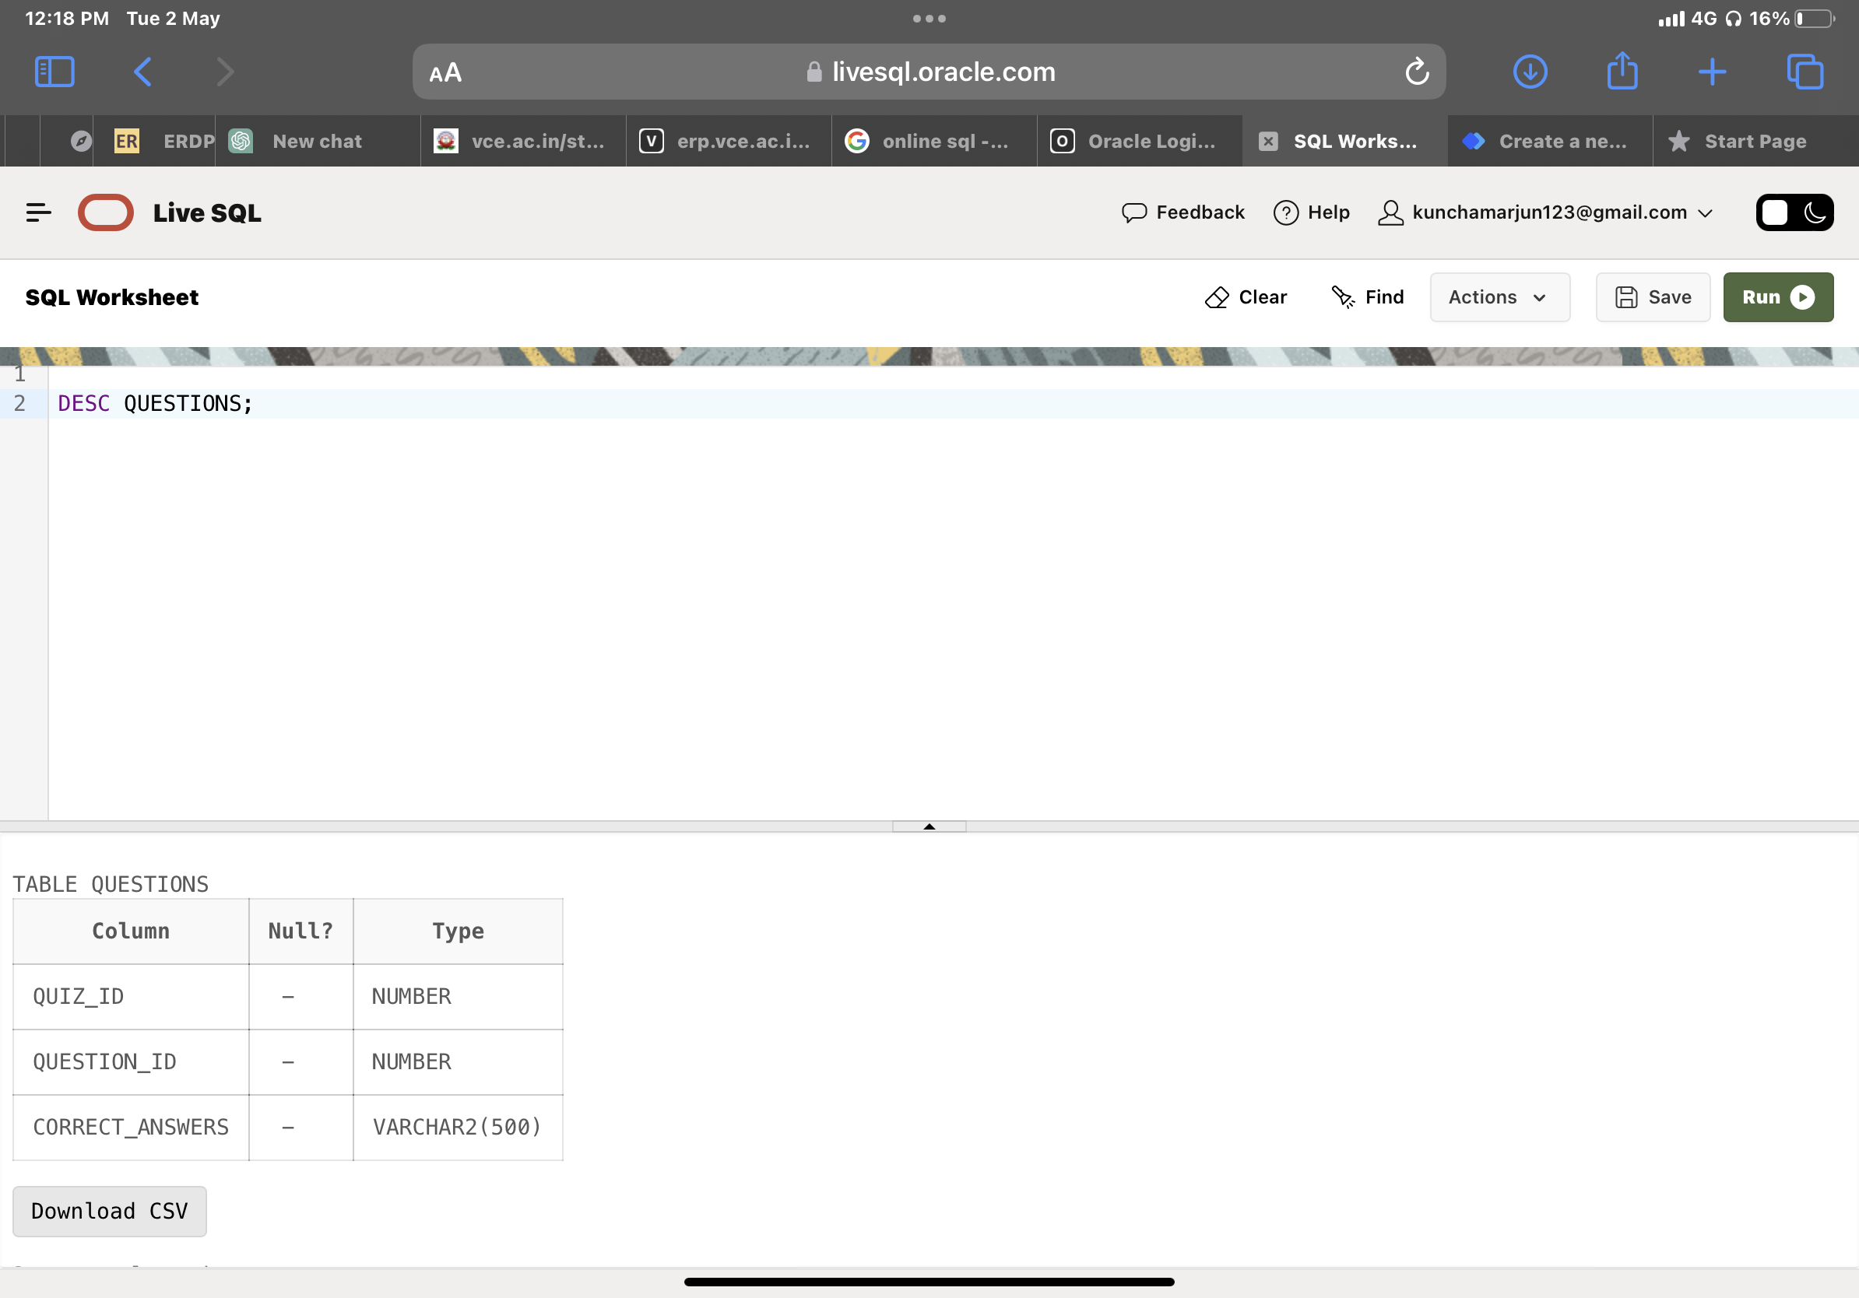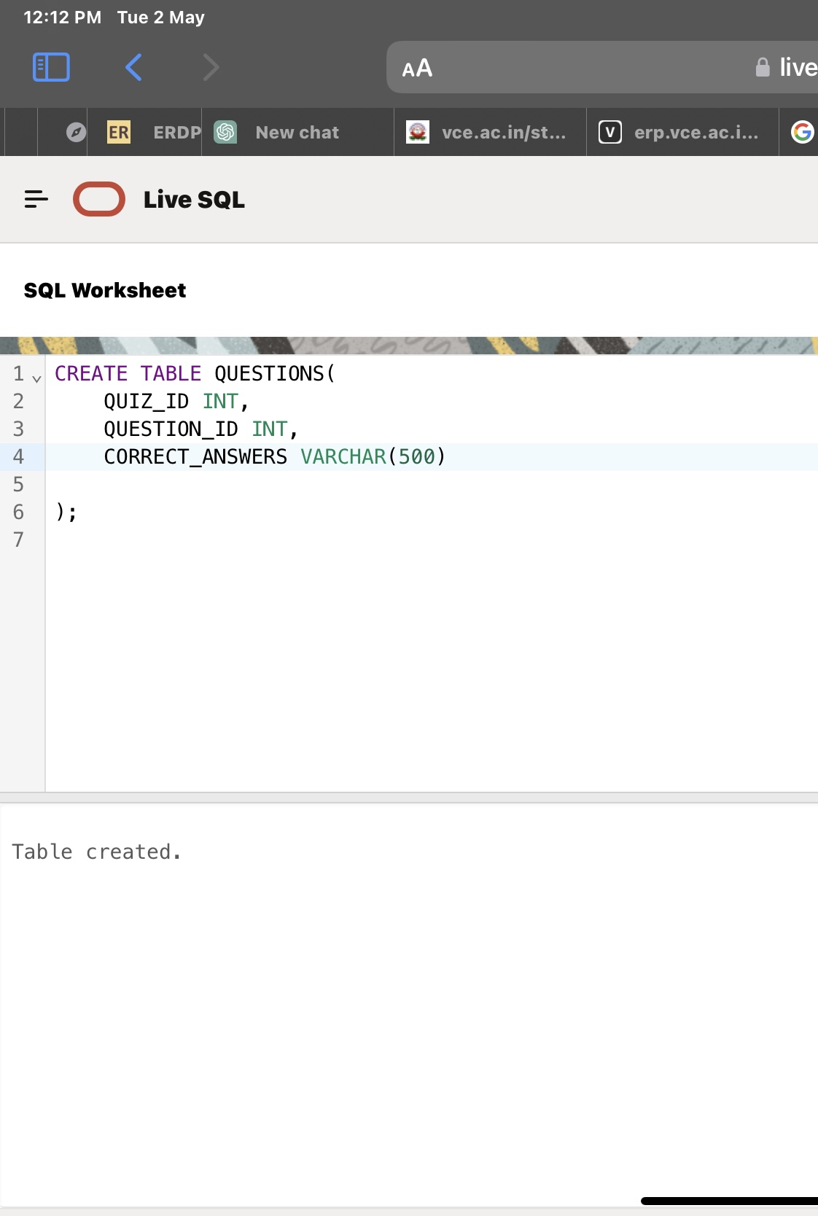

4.Score table

 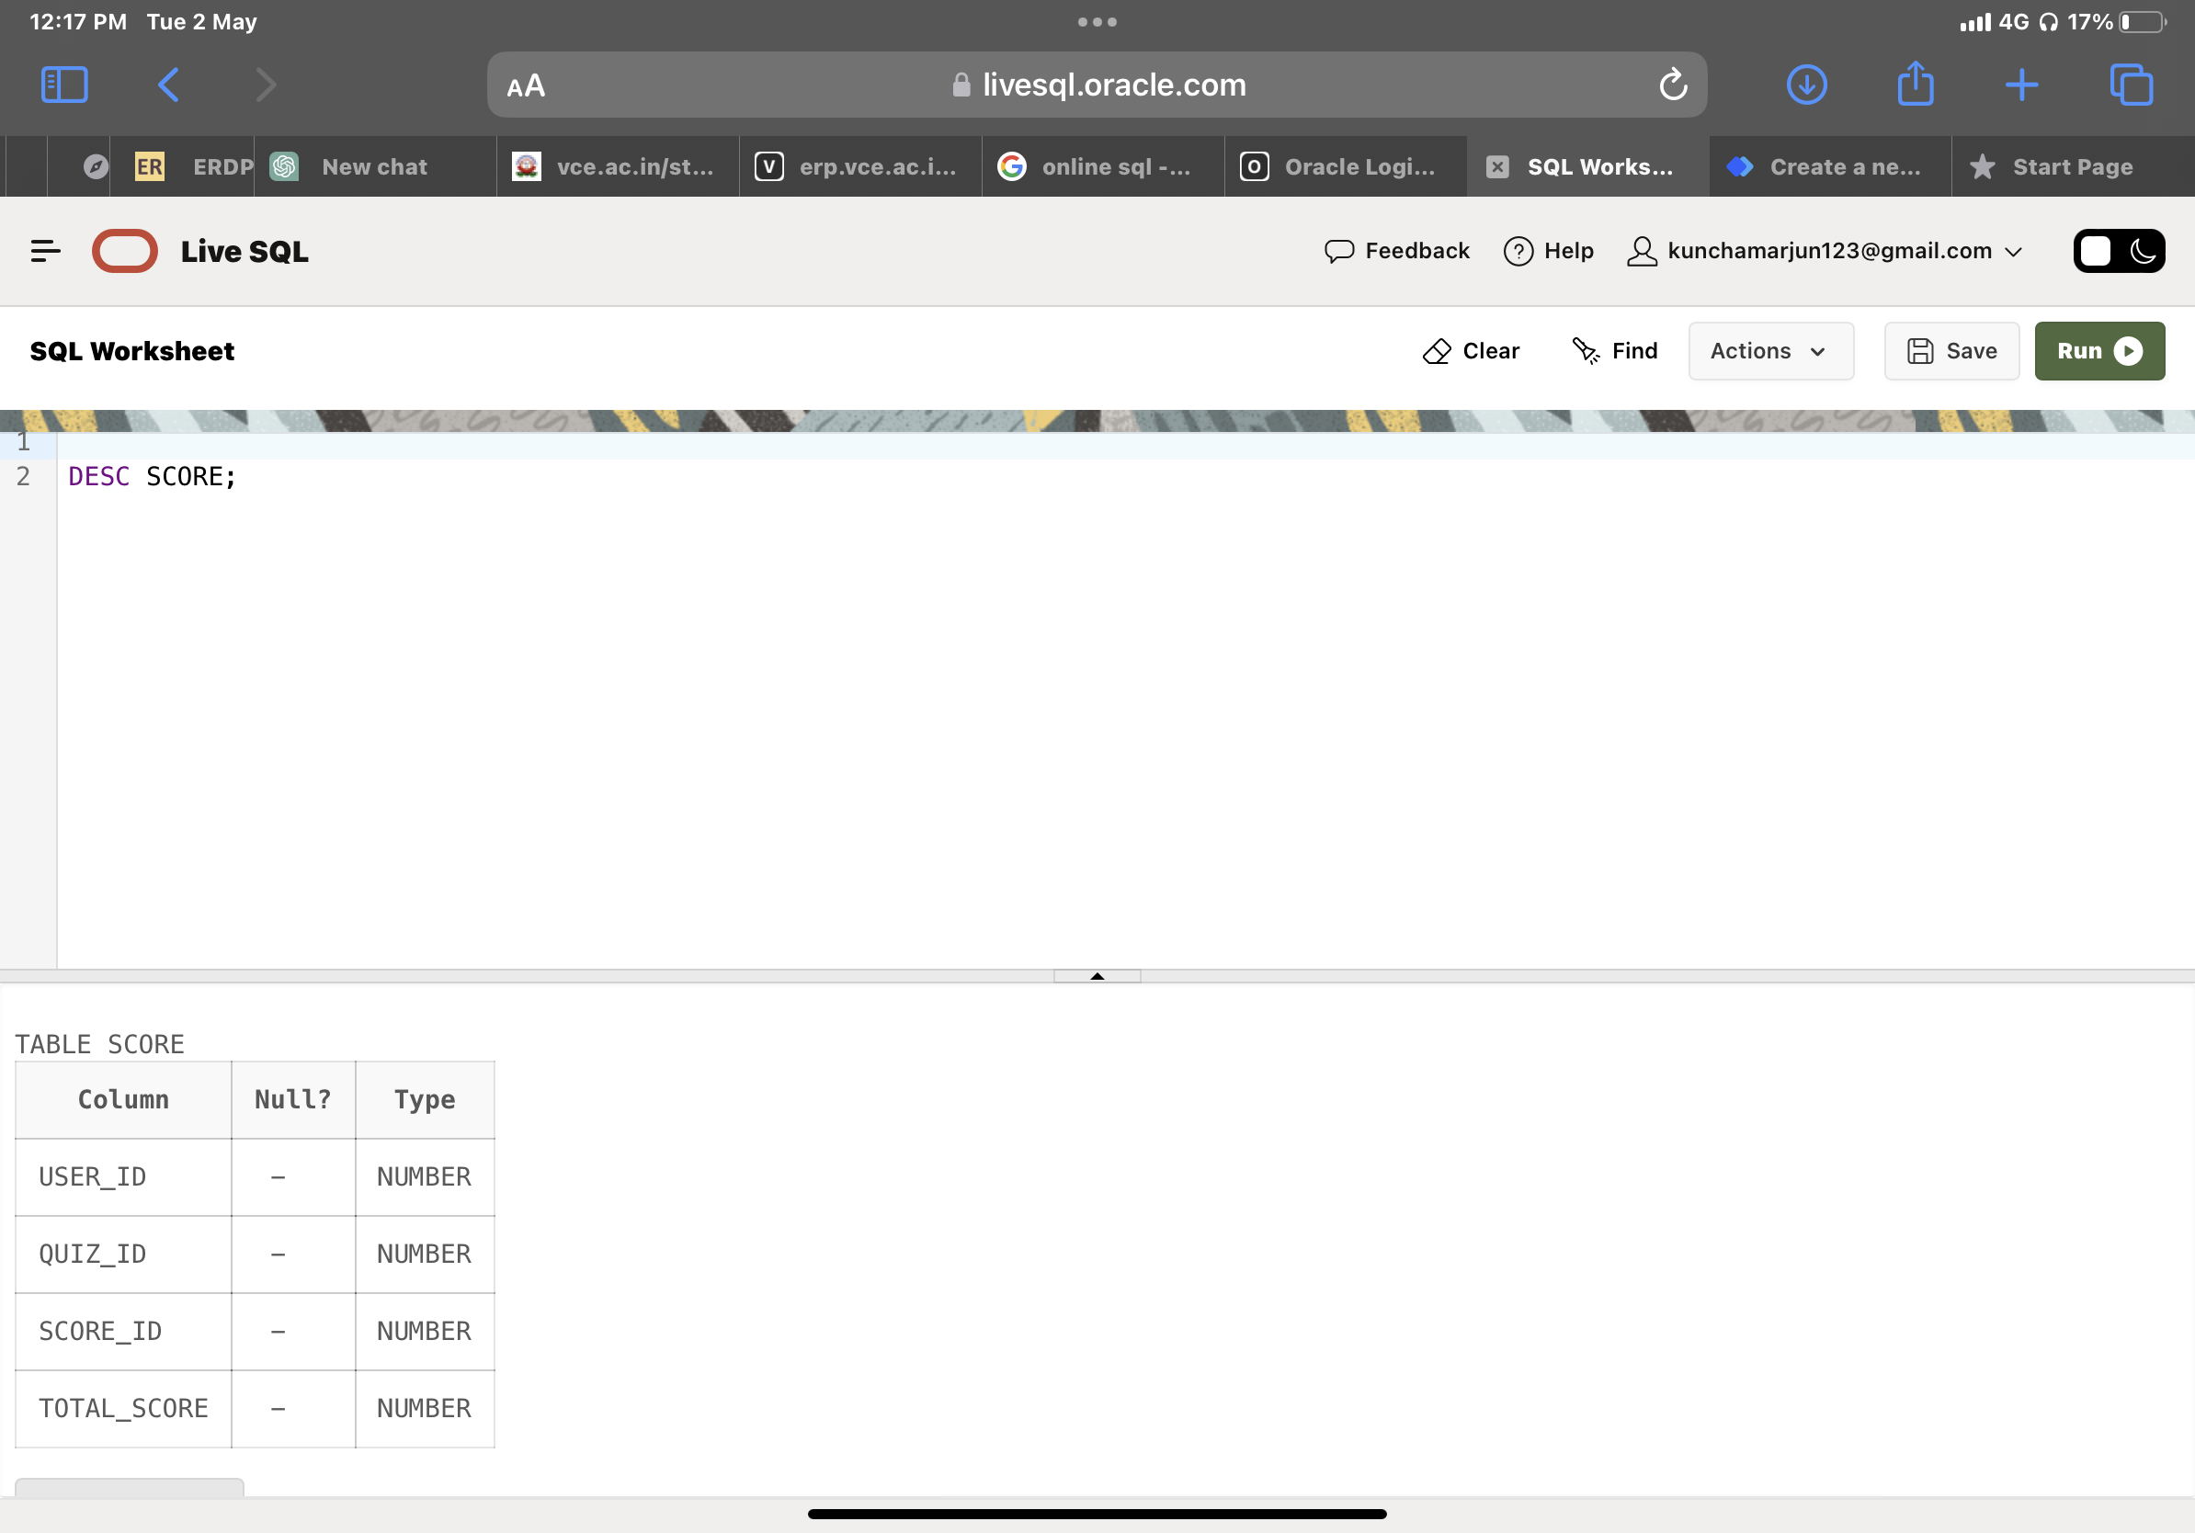

**DML Operations**

**1.Inserting Into user**

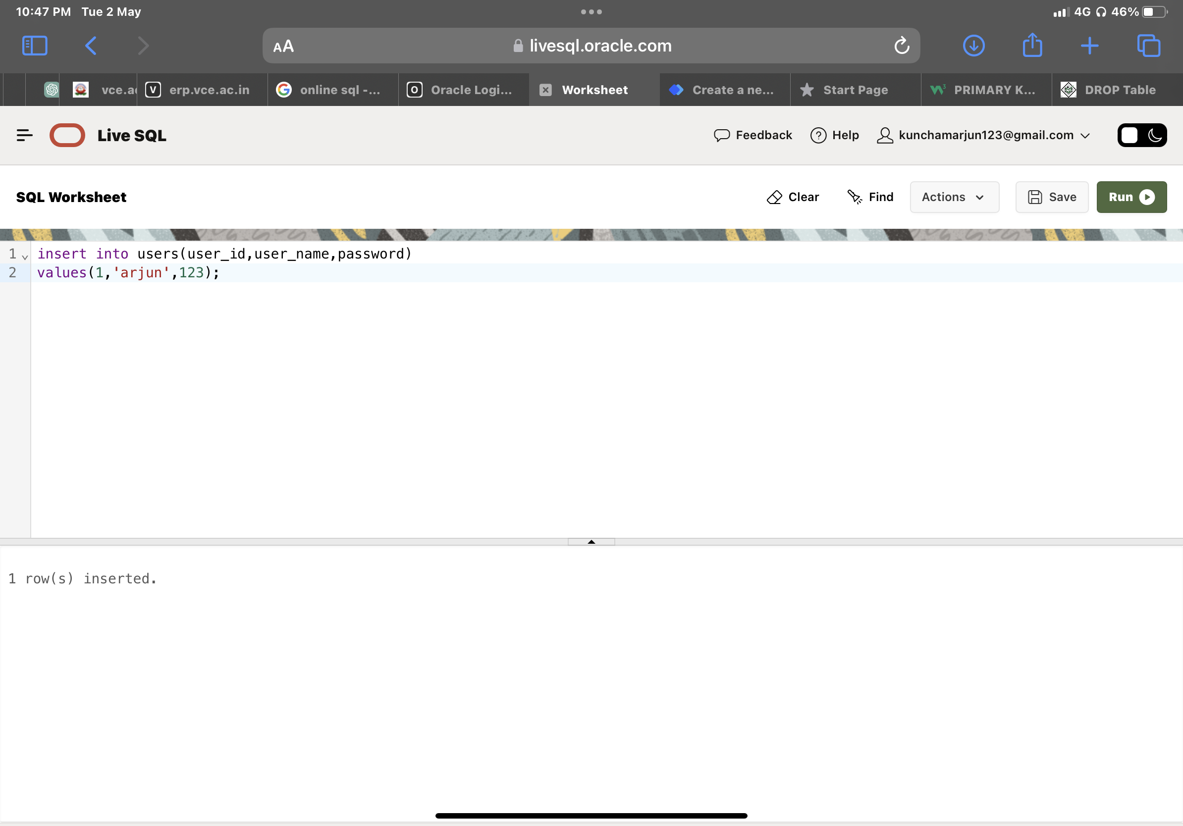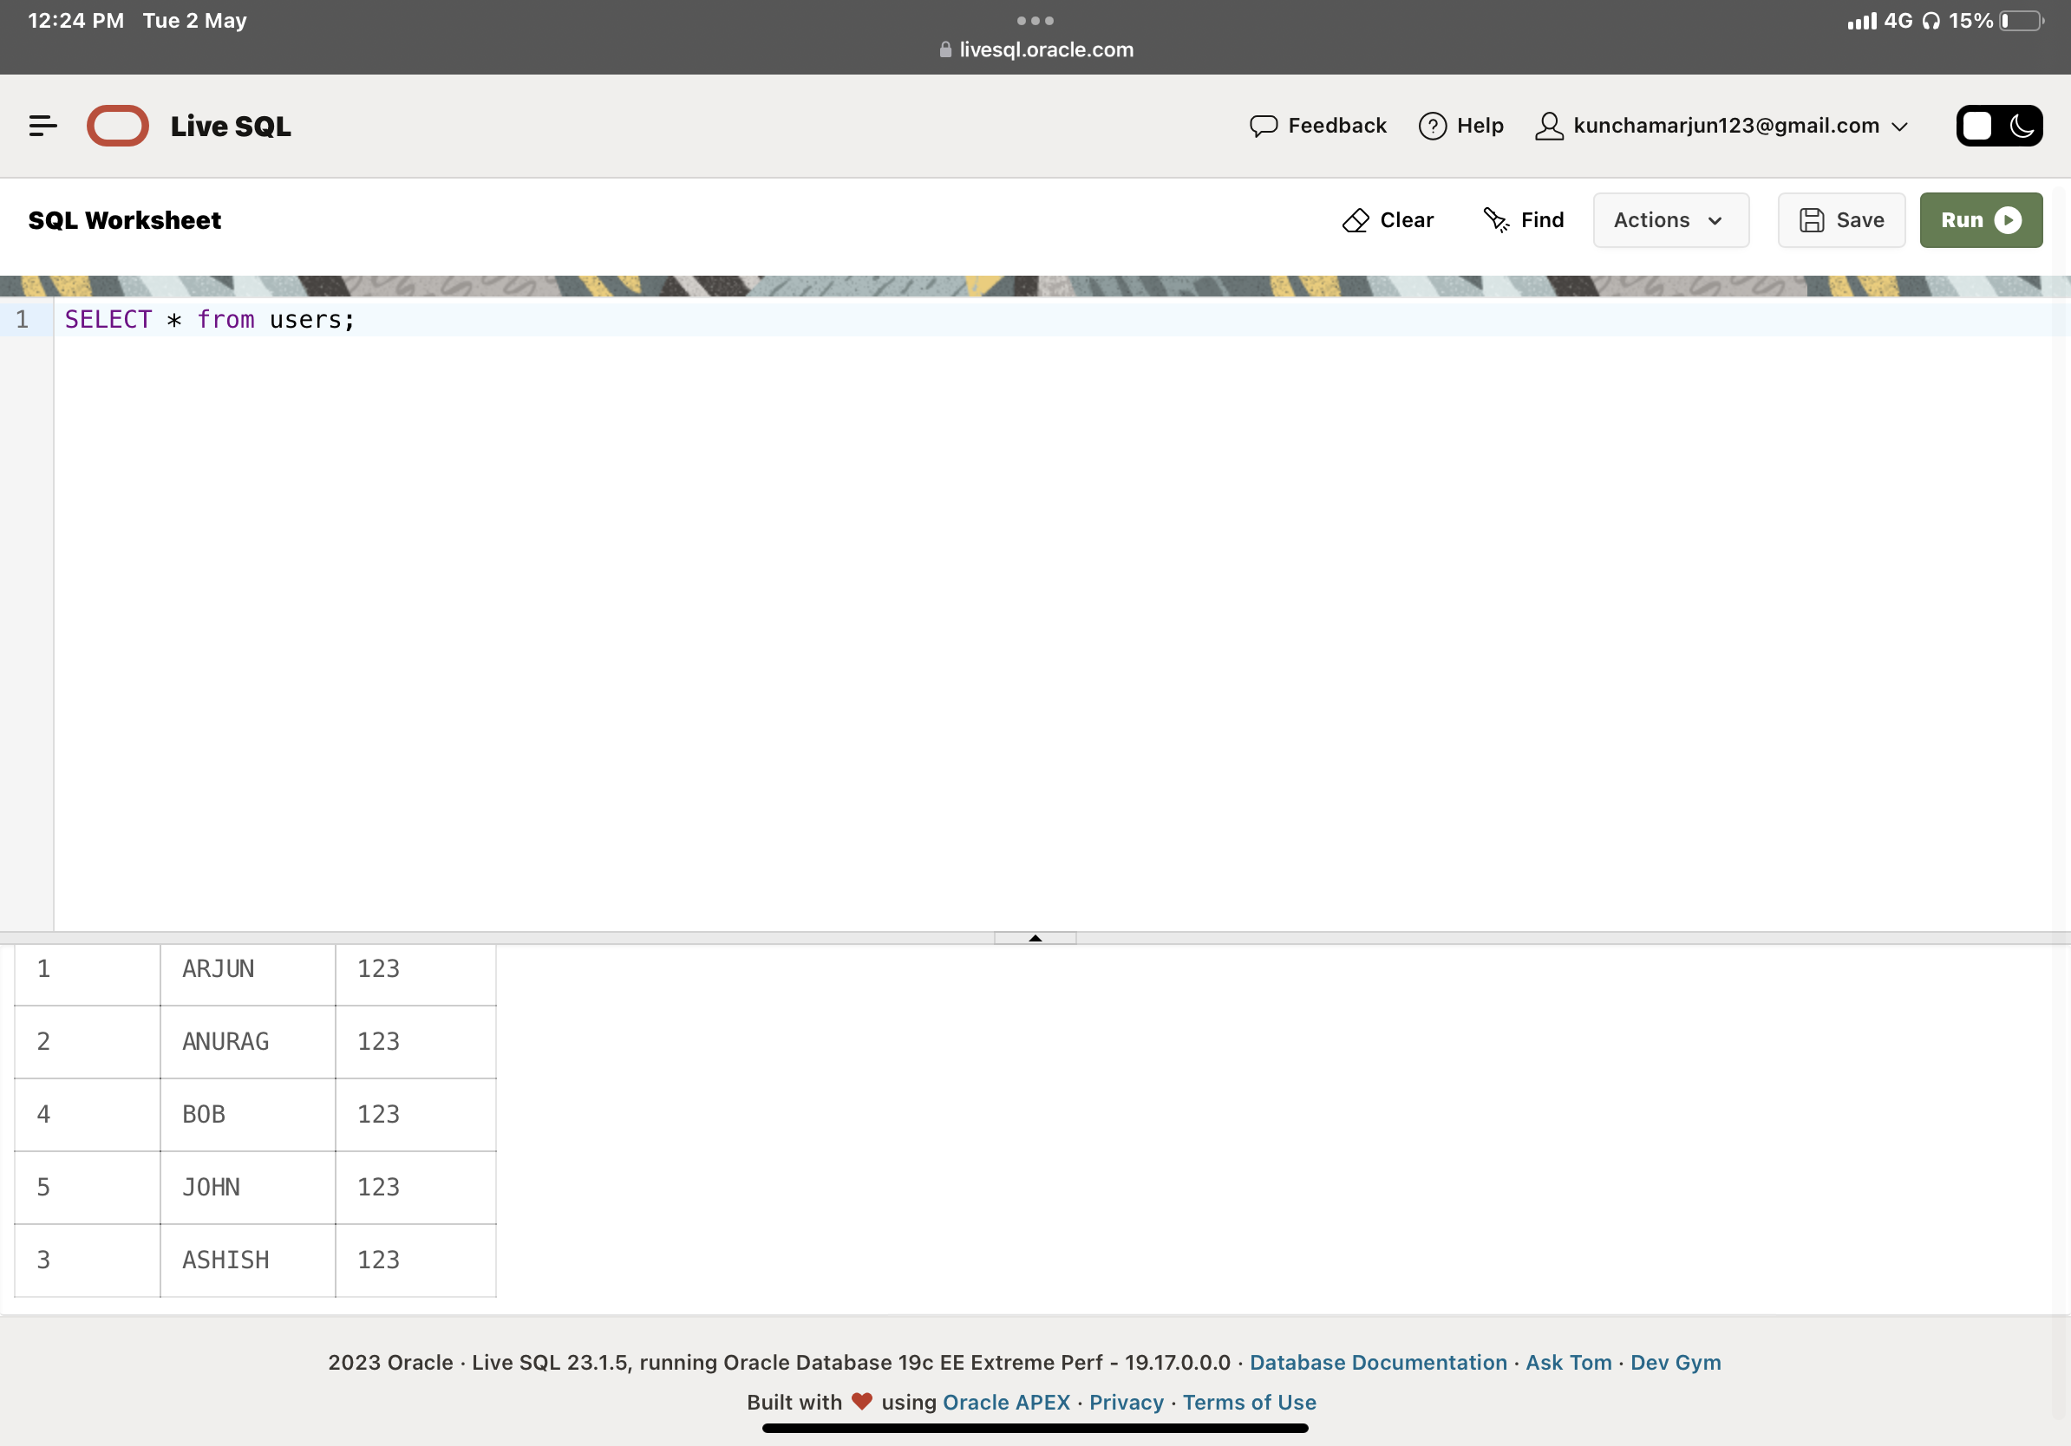

**2.Inserting Into Quiz**

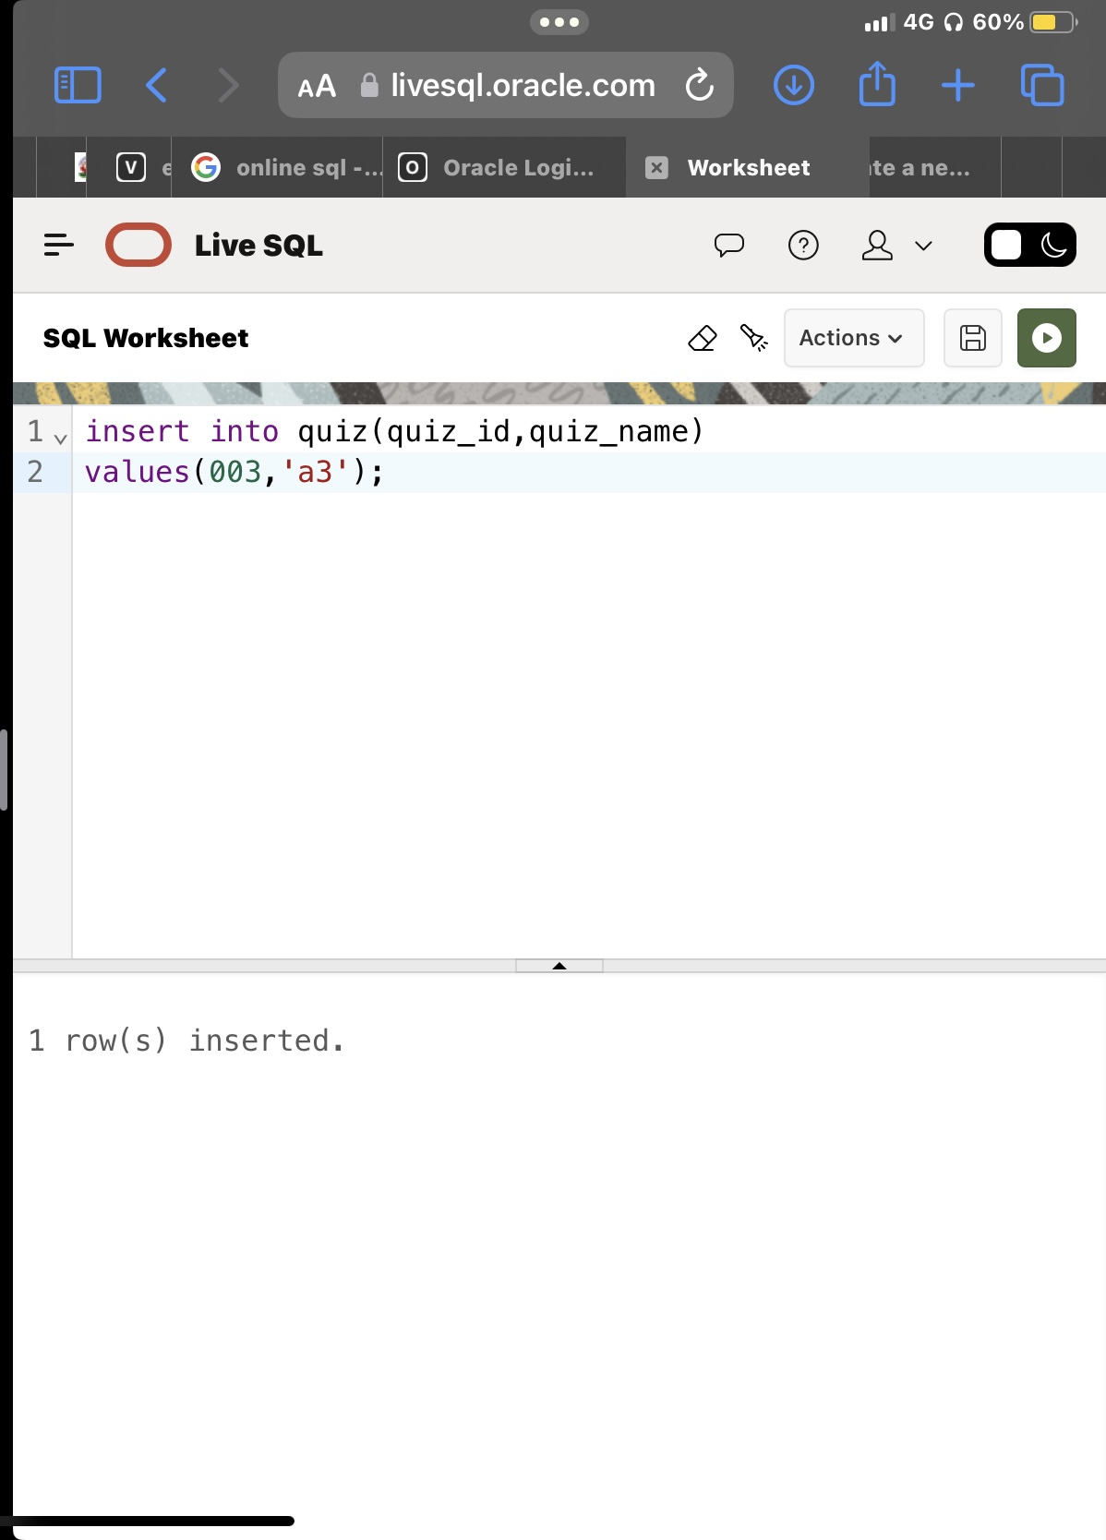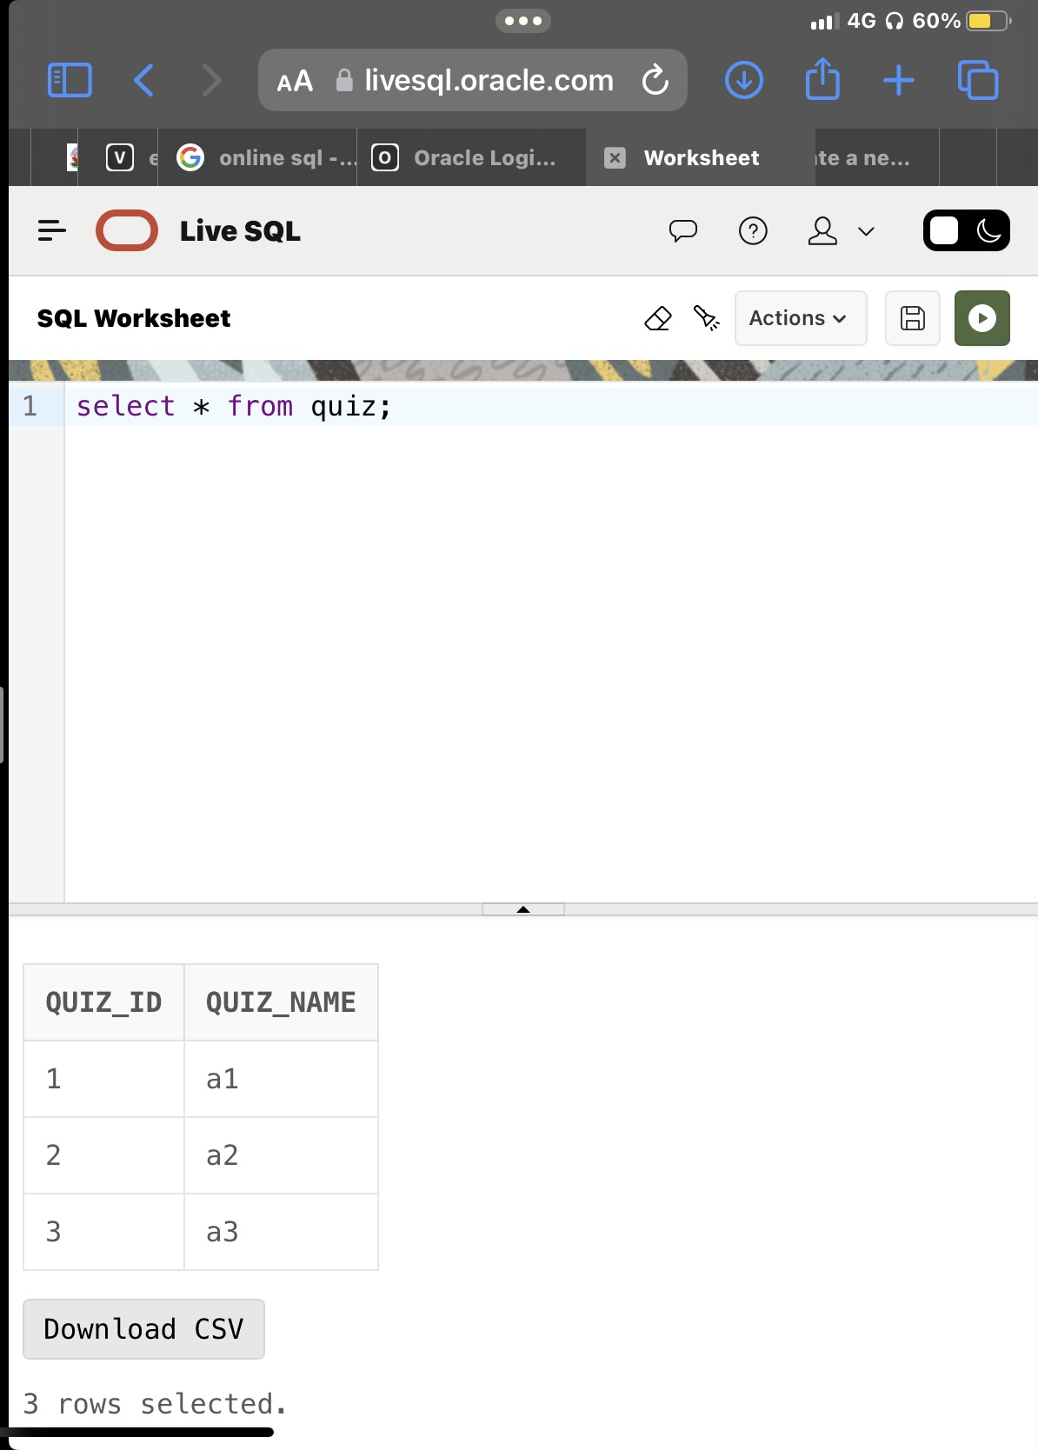

**3.creating a table for question**



**4.Inserting into score**

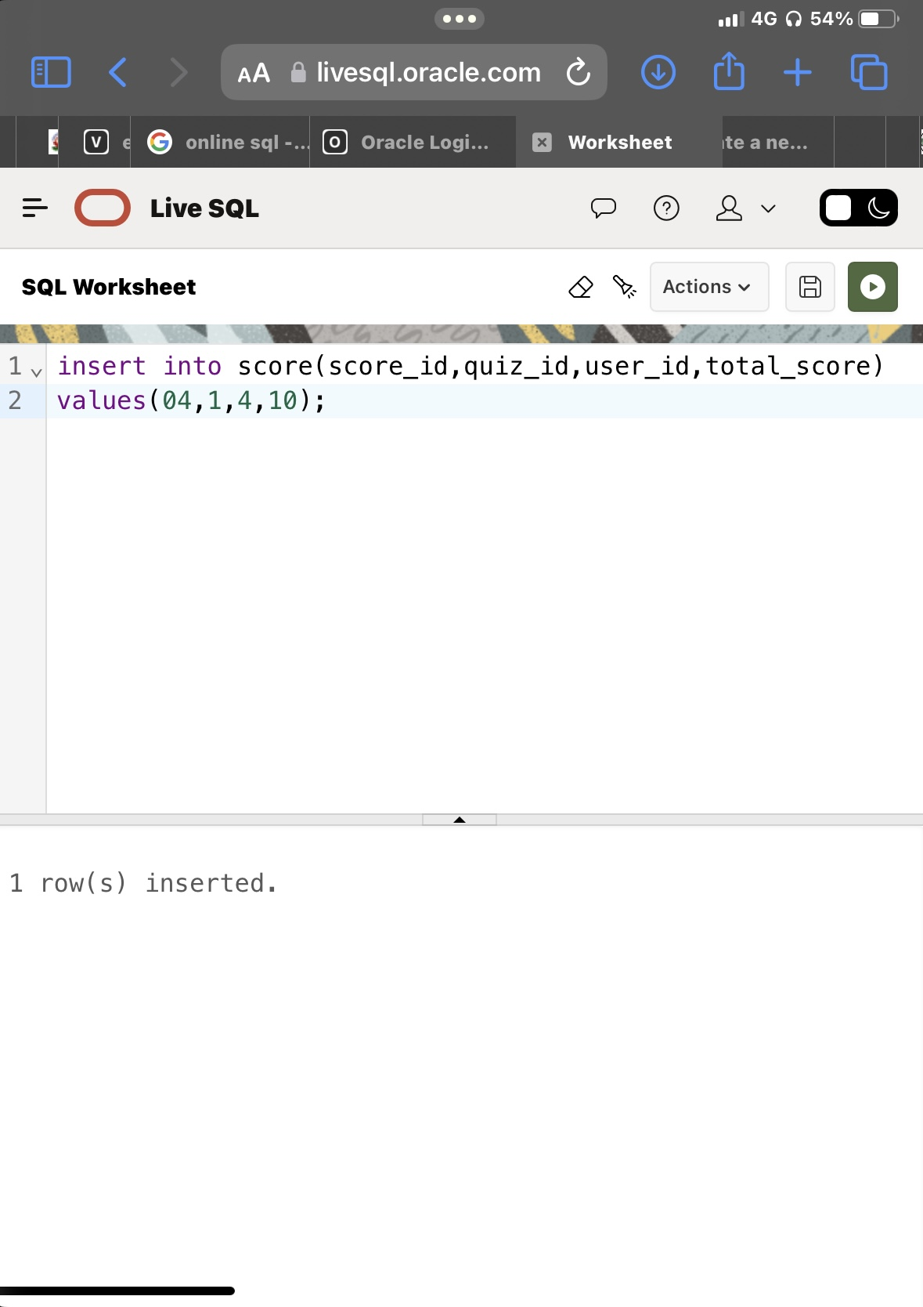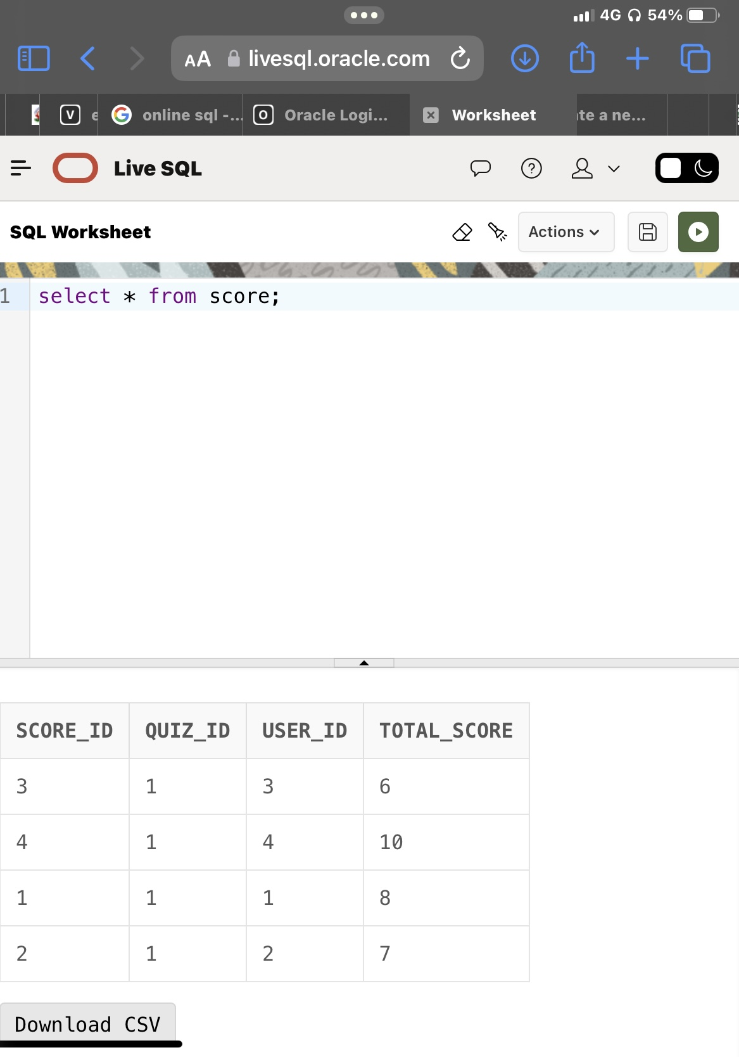

## IMPLEMENTATION

**JAVA-SQL Connectivity using JDBC:**

**Java Database Connectivity (JDBC)** is an application programming interface (API) for the programming language Java, which defines how a client may access a database. It is a Java-based data access technology used for Java database connectivity. It is part of the Java Standard Edition platform, from Oracle Corporation. It provides methods to query and update data in a database and is oriented towards relational databases.

The connection to the database can be performed using Java programming (JDBC API) as:

{

DriverManager.registerDriver(new oracle.jdbc.driver.OracleDriver());

// Connect to Oracle Database

Connection con = DriverManager.getConnection("jdbc:oracle:thin:@localhost:1521:XE" ,"arjun","kuncham");

Statement statement = con.createStatement()

String query = "UPDATE SKILLS SET SS1=" +"'"+ jTextField3.getText() +"',SS2=" +"'"+

jTextField5.getText() +"', AOI ="+" '"+ jTextField2.getText() +"' WHERE SID =+" + jTextField4.getText();

ResultSet rs = statement.executeQuery(query);

JOptionPane.showMessageDialog(new JFrame(), "Upadated Successfully", "INFORMATION", JOptionPane.INFORMATION_MESSAGE);

rs.close(); statement.close(); con.close(); }

### Front end programs:

### import javax.swing.*;

### import java.awt.*;

### import java.awt.event.ActionEvent;

### import java.awt.event.ActionListener;

### import java.sql.*;

### public class QuizTechie extends JFrame implements ActionListener {

### private JComboBox<String> tableComboBox;

### private JButton insertButton, updateButton, deleteButton;

### public QuizTechie() {

### super("Quiz Techie");

### setDefaultCloseOperation(JFrame.EXIT_ON_CLOSE);

### // Create the menu bar

### 

### // Create the menu items for each table

### 

### // Set layout for the main content pane

### setLayout(new FlowLayout());

### // Create the combo box, buttons, and add them to the content pane

### tableComboBox = new JComboBox<>();

### tableComboBox.addItem("quiz");

### tableComboBox.addItem("users");

### tableComboBox.addItem("questions");

### tableComboBox.addItem("score");

### add(tableComboBox);

### insertButton = new JButton("Submit");

### updateButton = new JButton("Modify");

### deleteButton = new JButton("Delete");

### insertButton.addActionListener(this);

### updateButton.addActionListener(this);

### deleteButton.addActionListener(this);

### add(insertButton);

### add(updateButton);

### add(deleteButton);

### setSize(600, 400);

### setLocationRelativeTo(null);

### setResizable(true);

### }

### public void actionPerformed(ActionEvent e) {

### String command = e.getActionCommand();

### if (command.equals("quiz") || command.equals("users") || command.equals("questions") || command.equals("score")) {

### tableComboBox.setSelectedItem(command);

### } else if (e.getSource() == insertButton) {

### performInsert();

### } else if (e.getSource() == updateButton) {

### performUpdate();

### } else if (e.getSource() == deleteButton) {

### performDelete();

### }

### }

### private void performInsert() {

### String tableName = (String) tableComboBox.getSelectedItem();

### switch (tableName) {

### case "quiz":

### performCreateQuiz();

### break;

### case "users":

### performCreateUser();

### break;

### case "questions":

### performCreateQuestion();

### break;

### case "score":

### performCreateScore();

### break;

### }

### }

### private void performUpdate() {

### String tableName = (String) tableComboBox.getSelectedItem();

### switch (tableName) {

### case "quiz":

### performUpdateQuiz();

### break;

### case "users":

### performUpdateUser();

### break;

### case "questions":

### performUpdateQuestion();

### break;

### case "score":

### performUpdateScore();

### break;

### }

### }

### private void performDelete() {

### String tableName = (String) tableComboBox.getSelectedItem();

### switch (tableName) {

### case "quiz":

### performDeleteQuiz();

### break;

### case "users":

### performDeleteUser();

### break;

### case "questions":

### performDeleteQuestion();

### break;

### case "score":

### performDeleteScore();

### break;

### }

### }

### // Rest of the code...

### 

### private void performCreateQuiz() {

### String quizId=JOptionPane.showInputDialog(null, "Enter quiz id:");

### String quizName = JOptionPane.showInputDialog(null, "Enter quiz name:");

### createQuiz(quizId,quizName);

### }

### private void createQuiz(String quizId,String quizName) {

### try {

### Connection connection = getConnection();

### int quizid=Integer.parseInt(quizId);

### String sql = "INSERT INTO quiz (quiz_id,quiz_name) VALUES (?,?)";

### PreparedStatement statement = connection.prepareStatement(sql);

### statement.setInt(1, quizid);

### statement.setString(2, quizName);

### statement.executeUpdate();

### statement.close();

### connection.close();

### JOptionPane.showMessageDialog(null, "Quiz created successfully!");

### } catch (SQLException ex) {

### JOptionPane.showMessageDialog(null, "Error: " + ex.getMessage());

### }

### }

### private void performCreateUser() {

### String userID = JOptionPane.showInputDialog(null, "Enter user id:");

### String userName = JOptionPane.showInputDialog(null, "Enter user name:");

### String password = JOptionPane.showInputDialog(null, "Enter password:");

### createUser(userID,userName, password);

### }

### private void createUser(String userID,String userName, String password) {

### try {

### Connection connection = getConnection();

### int userid=Integer.parseInt(userID);

### String sql = "INSERT INTO users (user_id,user_name, password) VALUES (?,?, ?)";

### PreparedStatement statement = connection.prepareStatement(sql);

### 

### statement.setInt(1, userid);

### statement.setString(2, userName);

### statement.setString(3, password);

### statement.executeUpdate();

### statement.close();

### connection.close();

### JOptionPane.showMessageDialog(null, "User created successfully!");

### } catch (SQLException ex) {

### JOptionPane.showMessageDialog(null, "Error: " + ex.getMessage());

### }

### }

### private void performCreateQuestion() {

### int questionId = Integer.parseInt(JOptionPane.showInputDialog(null, "Enter the question ID:"));

### String correctAnswers = JOptionPane.showInputDialog(null, "Enter the correct answer:");

### int quizId= Integer.parseInt(JOptionPane.showInputDialog(null, "Enter the quiz id:"));

### createQuestion(questionId,correctAnswers,quizId);

### }

### private void createQuestion(int questionId, String correctAnswers, int quizId) {

### try {

### Connection connection = getConnection();

### String sql = "INSERT INTO questions (question_id, correct_answers,quiz_id) VALUES (?, ?, ?)";

### PreparedStatement statement = connection.prepareStatement(sql);

### statement.setInt(1, questionId);

### statement.setString(2, correctAnswers);

### statement.setInt(3, quizId);

### statement.executeUpdate();

### statement.close();

### connection.close();

### JOptionPane.showMessageDialog(null, "Question created successfully!");

### } catch (SQLException ex) {

### JOptionPane.showMessageDialog(null, "Error: " + ex.getMessage());

### }

### }

### private void performCreateScore() {

### int quizId = Integer.parseInt(JOptionPane.showInputDialog(null, "Enter the quiz ID:"));

### int userId = Integer.parseInt(JOptionPane.showInputDialog(null, "Enter the user ID:"));

### int scoreId = Integer.parseInt(JOptionPane.showInputDialog(null, "Enter the score ID:"));

### int totalScore = Integer.parseInt(JOptionPane.showInputDialog(null, "Enter the total score:"));

### createScore(quizId, userId, scoreId, totalScore);

### }

### private void createScore(int quizId, int userId, int scoreId, int totalScore) {

### try {

### Connection connection = getConnection();

### String sql = "INSERT INTO score (quiz_id, user_id,score_id, total_score) VALUES (?, ?, ?, ?)";

### PreparedStatement statement = connection.prepareStatement(sql);

### statement.setInt(1, quizId);

### statement.setInt(2, userId);

### statement.setInt(3, scoreId);

### statement.setInt(4, totalScore);

### statement.executeUpdate();

### statement.close();

### connection.close();

### JOptionPane.showMessageDialog(null, "Score created successfully!");

### } catch (SQLException ex) {

### JOptionPane.showMessageDialog(null, "Error: " + ex.getMessage());

### }

### }

### private void performUpdateQuiz() {

### int quizId = Integer.parseInt(JOptionPane.showInputDialog(null, "Enter the quiz ID:"));

### String quizName = JOptionPane.showInputDialog(null, "Enter the new quiz name:");

### updateQuiz(quizId, quizName);

### }

### private void updateQuiz(int quizId, String quizName) {

### try {

### Connection connection = getConnection();

### String sql = "UPDATE quiz SET quiz_name = ? WHERE quiz_id = ?";

### PreparedStatement statement = connection.prepareStatement(sql);

### statement.setString(1, quizName);

### statement.setInt(2, quizId);

### statement.executeUpdate();

### statement.close();

### connection.close();

### JOptionPane.showMessageDialog(null, "Quiz updated successfully!");

### } catch (SQLException ex) {

### JOptionPane.showMessageDialog(null, "Error: " + ex.getMessage());

### }

### }

### private void performUpdateUser() {

### int userId = Integer.parseInt(JOptionPane.showInputDialog(null, "Enter the user ID:"));

### String userName = JOptionPane.showInputDialog(null, "Enter the new user name:");

### String password = JOptionPane.showInputDialog(null, "Enter the new password:");

### updateUser(userId, userName, password);

### }

### private void updateUser(int userId, String userName, String password) {

### try {

### Connection connection = getConnection();

### String sql = "UPDATE users SET user_name = ?, password = ? WHERE user_id = ?";

### PreparedStatement statement = connection.prepareStatement(sql);

### statement.setString(1, userName);

### statement.setString(2, password);

### statement.setInt(3, userId);

### statement.executeUpdate();

### statement.close();

### connection.close();

### JOptionPane.showMessageDialog(null, "User updated successfully!");

### } catch (SQLException ex) {

### JOptionPane.showMessageDialog(null, "Error: " + ex.getMessage());

### }

### }

### private void performUpdateQuestion() {

### int questionId = Integer.parseInt(JOptionPane.showInputDialog(null, "Enter the question ID:"));

### String correctAnswer = JOptionPane.showInputDialog(null, "Enter the new correct answer:");

### int quizId = Integer.parseInt(JOptionPane.showInputDialog(null, "Enter the quiz ID:"));

### updateQuestion(questionId, correctAnswer,quizId);

### }

### private void updateQuestion(int questionId, String correctAnswer,int quizId) {

### try {

### Connection connection = getConnection();

### String sql = "UPDATE questions SET correct_answers = ?,quiz_id=? WHERE question_id = ?";

### PreparedStatement statement = connection.prepareStatement(sql);

### 

### statement.setString(1, correctAnswer);

### statement.setInt(2,quizId);

### statement.setInt(3, questionId);

### statement.executeUpdate();

### statement.close();

### connection.close();

### JOptionPane.showMessageDialog(null, "Question updated successfully!");

### } catch (SQLException ex) {

### JOptionPane.showMessageDialog(null, "Error: " + ex.getMessage());

### }

### }

### private void performUpdateScore() {

### int scoreId = Integer.parseInt(JOptionPane.showInputDialog(null, "Enter the score ID:"));

### int totalScore = Integer.parseInt(JOptionPane.showInputDialog(null, "Enter the new total score:"));

### updateScore(scoreId, totalScore);

### }

### private void updateScore(int scoreId, int totalScore) {

### try {

### Connection connection = getConnection();

### String sql = "UPDATE score SET total_score = ? WHERE score_id = ?";

### PreparedStatement statement = connection.prepareStatement(sql);

### statement.setInt(1, totalScore);

### statement.setInt(2, scoreId);

### statement.executeUpdate();

### statement.close();

### connection.close();

### JOptionPane.showMessageDialog(null, "Score updated successfully!");

### } catch (SQLException ex) {

### JOptionPane.showMessageDialog(null, "Error: " + ex.getMessage());

### }

### }

### private void performDeleteQuiz() {

### int quizId = Integer.parseInt(JOptionPane.showInputDialog(null, "Enter the quiz ID:"));

### deleteQuiz(quizId);

### }

### private void deleteQuiz(int quizId) {

### try {

### Connection connection = getConnection();

### String sql = "DELETE FROM quiz WHERE quiz_id = ?";

### PreparedStatement statement = connection.prepareStatement(sql);

### statement.setInt(1, quizId);

### statement.executeUpdate();

### statement.close();

### connection.close();

### JOptionPane.showMessageDialog(null, "Quiz deleted successfully!");

### } catch (SQLException ex) {

### JOptionPane.showMessageDialog(null, "Error: " + ex.getMessage());

### }

### }

### private void performDeleteUser() {

### int userId = Integer.parseInt(JOptionPane.showInputDialog(null, "Enter the user ID:"));

### deleteUser(userId);

### }

### private void deleteUser(int userId) {

### try {

### Connection connection = getConnection();

### String sql = "DELETE FROM users WHERE user_id = ?";

### PreparedStatement statement = connection.prepareStatement(sql);

### statement.setInt(1, userId);

### statement.executeUpdate();

### statement.close();

### connection.close();

### JOptionPane.showMessageDialog(null, "User deleted successfully!");

### } catch (SQLException ex) {

### JOptionPane.showMessageDialog(null, "Error: " + ex.getMessage());

### }

### }

### private void performDeleteQuestion() {

### int questionId = Integer.parseInt(JOptionPane.showInputDialog(null, "Enter the question ID:"));

### deleteQuestion(questionId);

### }

### private void deleteQuestion(int questionId) {

### try {

### Connection connection = getConnection();

### String sql = "DELETE FROM questions WHERE question_id = ?";

### PreparedStatement statement = connection.prepareStatement(sql);

### statement.setInt(1, questionId);

### statement.executeUpdate();

### statement.close();

### connection.close();

### JOptionPane.showMessageDialog(null, "Question deleted successfully!");

### } catch (SQLException ex) {

### JOptionPane.showMessageDialog(null, "Error: " + ex.getMessage());

### }

### }

### private void performDeleteScore() {

### int scoreId = Integer.parseInt(JOptionPane.showInputDialog(null, "Enter the score ID:"));

### deleteScore(scoreId);

### }

### private void deleteScore(int scoreId) {

### try {

### Connection connection = getConnection();

### String sql = "DELETE FROM score WHERE score_id = ?";

### PreparedStatement statement = connection.prepareStatement(sql);

### statement.setInt(1, scoreId);

### statement.executeUpdate();

### statement.close();

### connection.close();

### JOptionPane.showMessageDialog(null, "Score deleted successfully!");

### } catch (SQLException ex) {

### JOptionPane.showMessageDialog(null, "Error: " + ex.getMessage());

### }

### }

### 

### private Connection getConnection() throws SQLException {

### String url = "jdbc:oracle:thin:@localhost:1521:xe";

### String username = "arjun";

### String password = "kuncham";

### 

### return DriverManager.getConnection(url, username, password);

### }

### public static void main(String[] args) {

### SwingUtilities.invokeLater(new Runnable() {

### public void run() {

### QuizTechie quizTechie = new QuizTechie();

### quizTechie.setVisible(true);

### }

### });

### }

### }

### GitHub Links and Folder Structure

**Link: https://github.com/Arjunkuncham/Techie-quiz-for-c-and-python#techie-quiz-for-c-and-python**

**Folder Structure:**

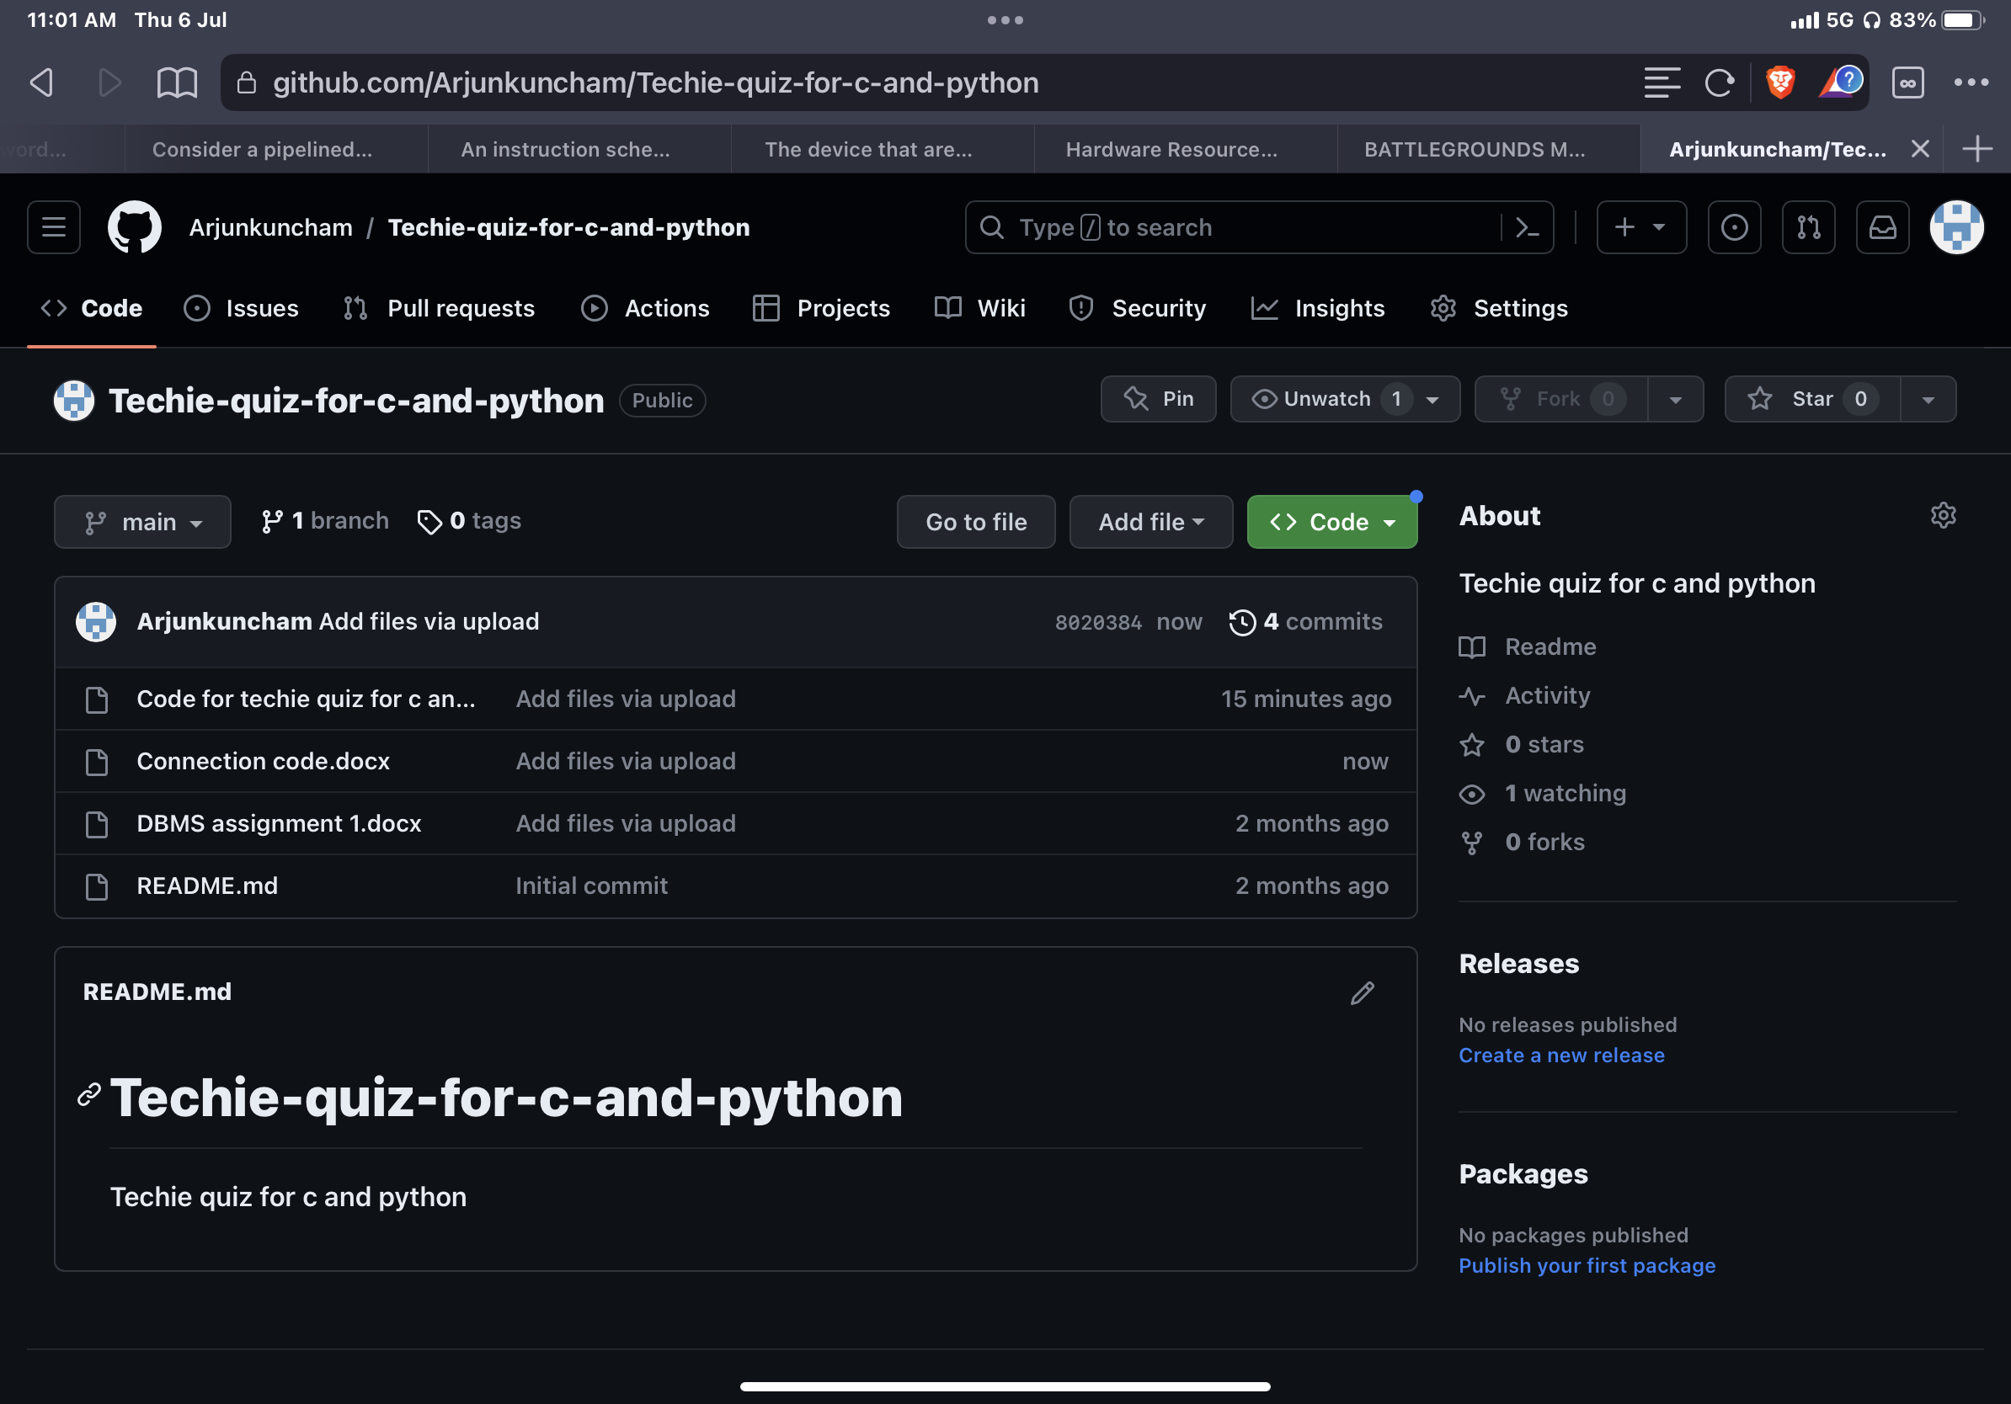

## TESTING

**I.ENTERING QUIZ ID**

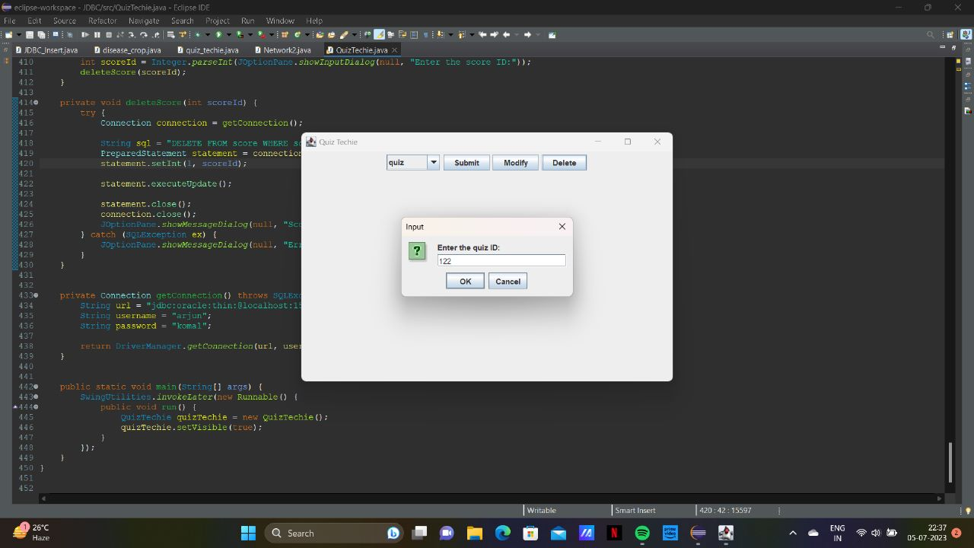

**II.DELETE QUIZ**

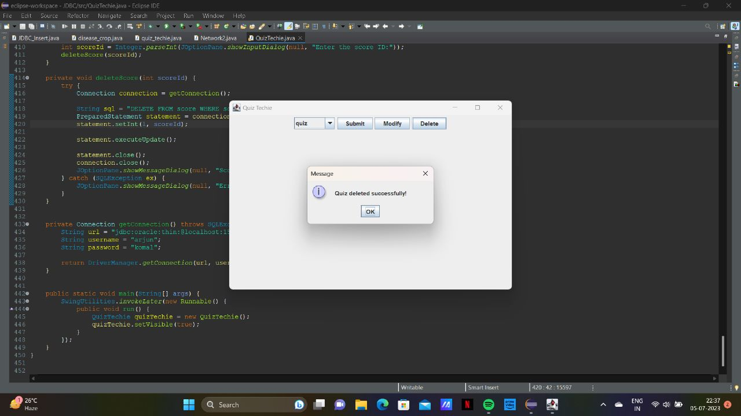

**3.ENTERING OF USER TABLE**

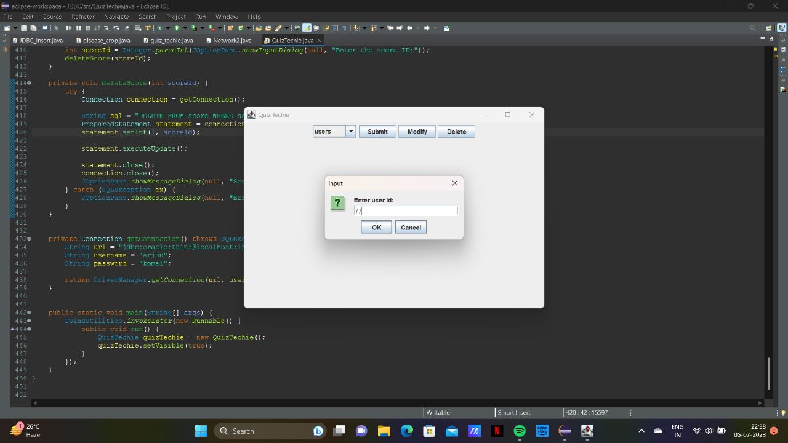

**4.UPDATION OF USER NAME**

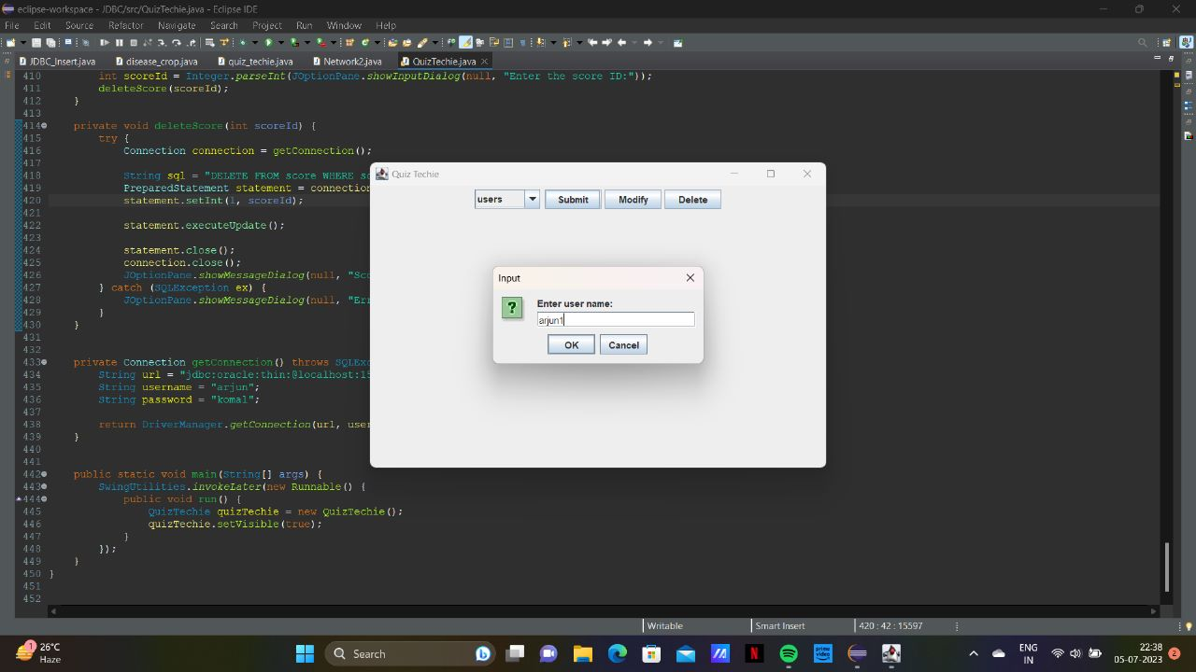

**5.ENTERING OF PASSWORD**

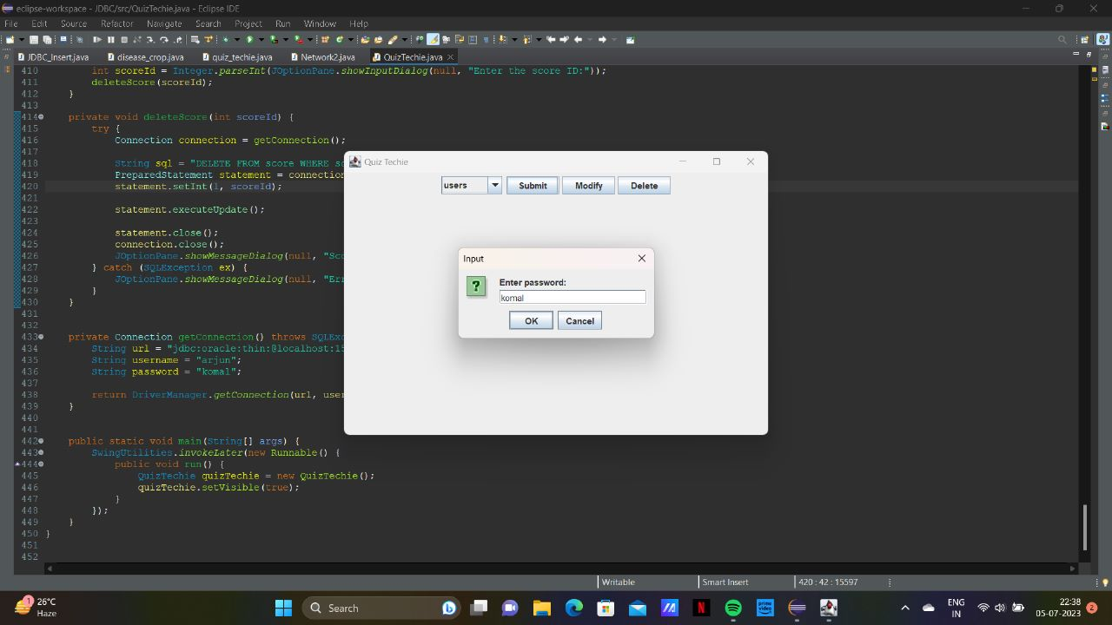

**5.CREATION OF USER**

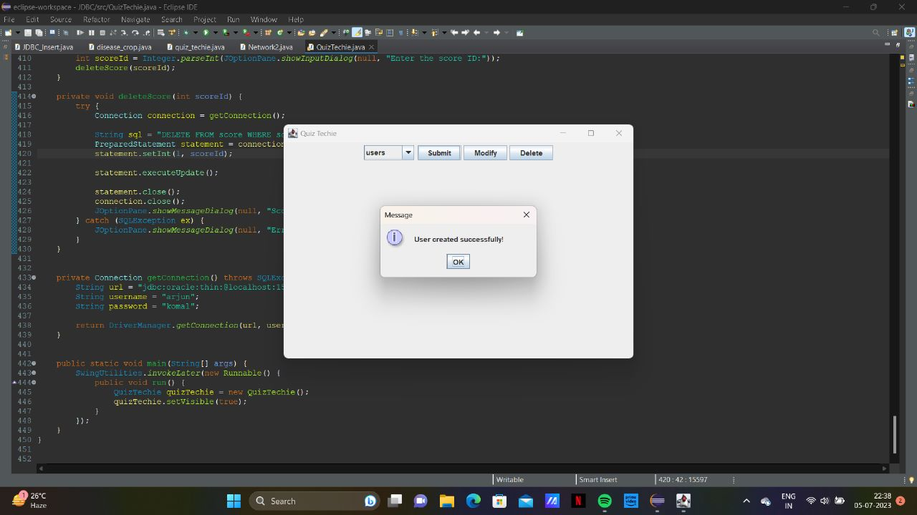

**6.DELETION OF USER**

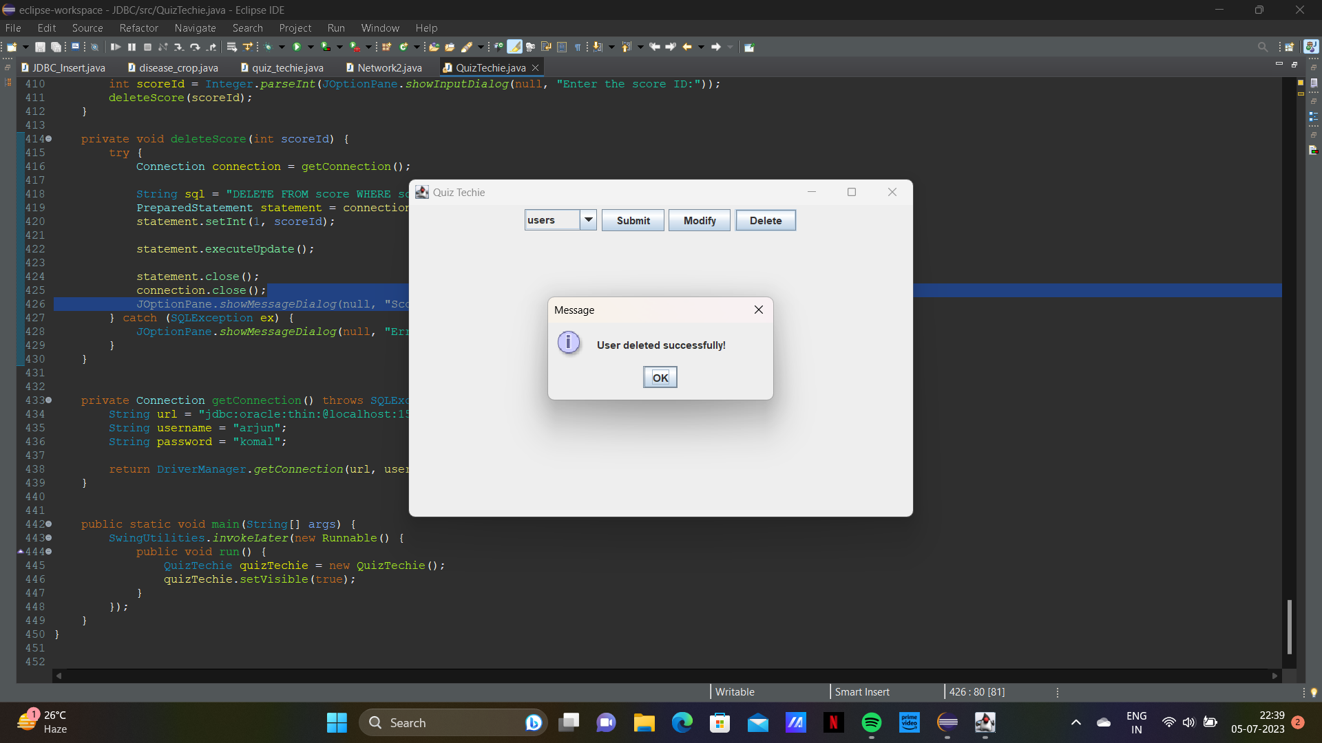

**7. UPDATE USER**

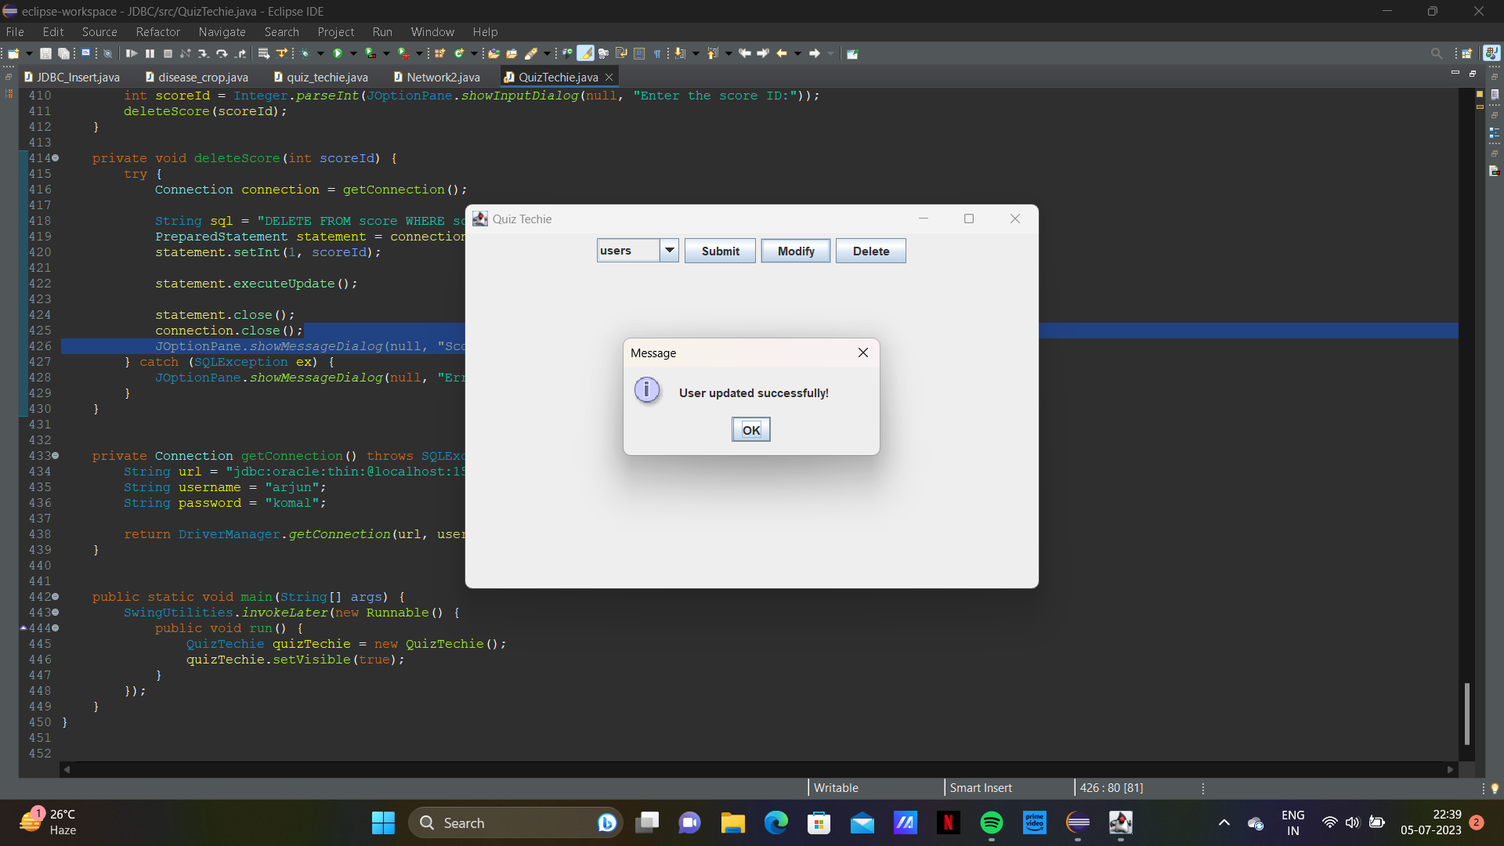

**8. ENTER QUESTION ID**

**\**

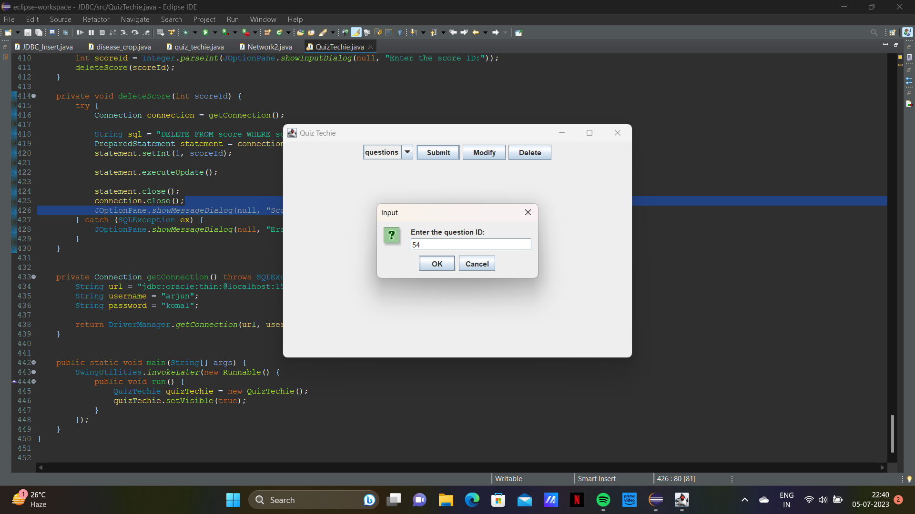

**9.ENTER THE CORRECT ANSWER**

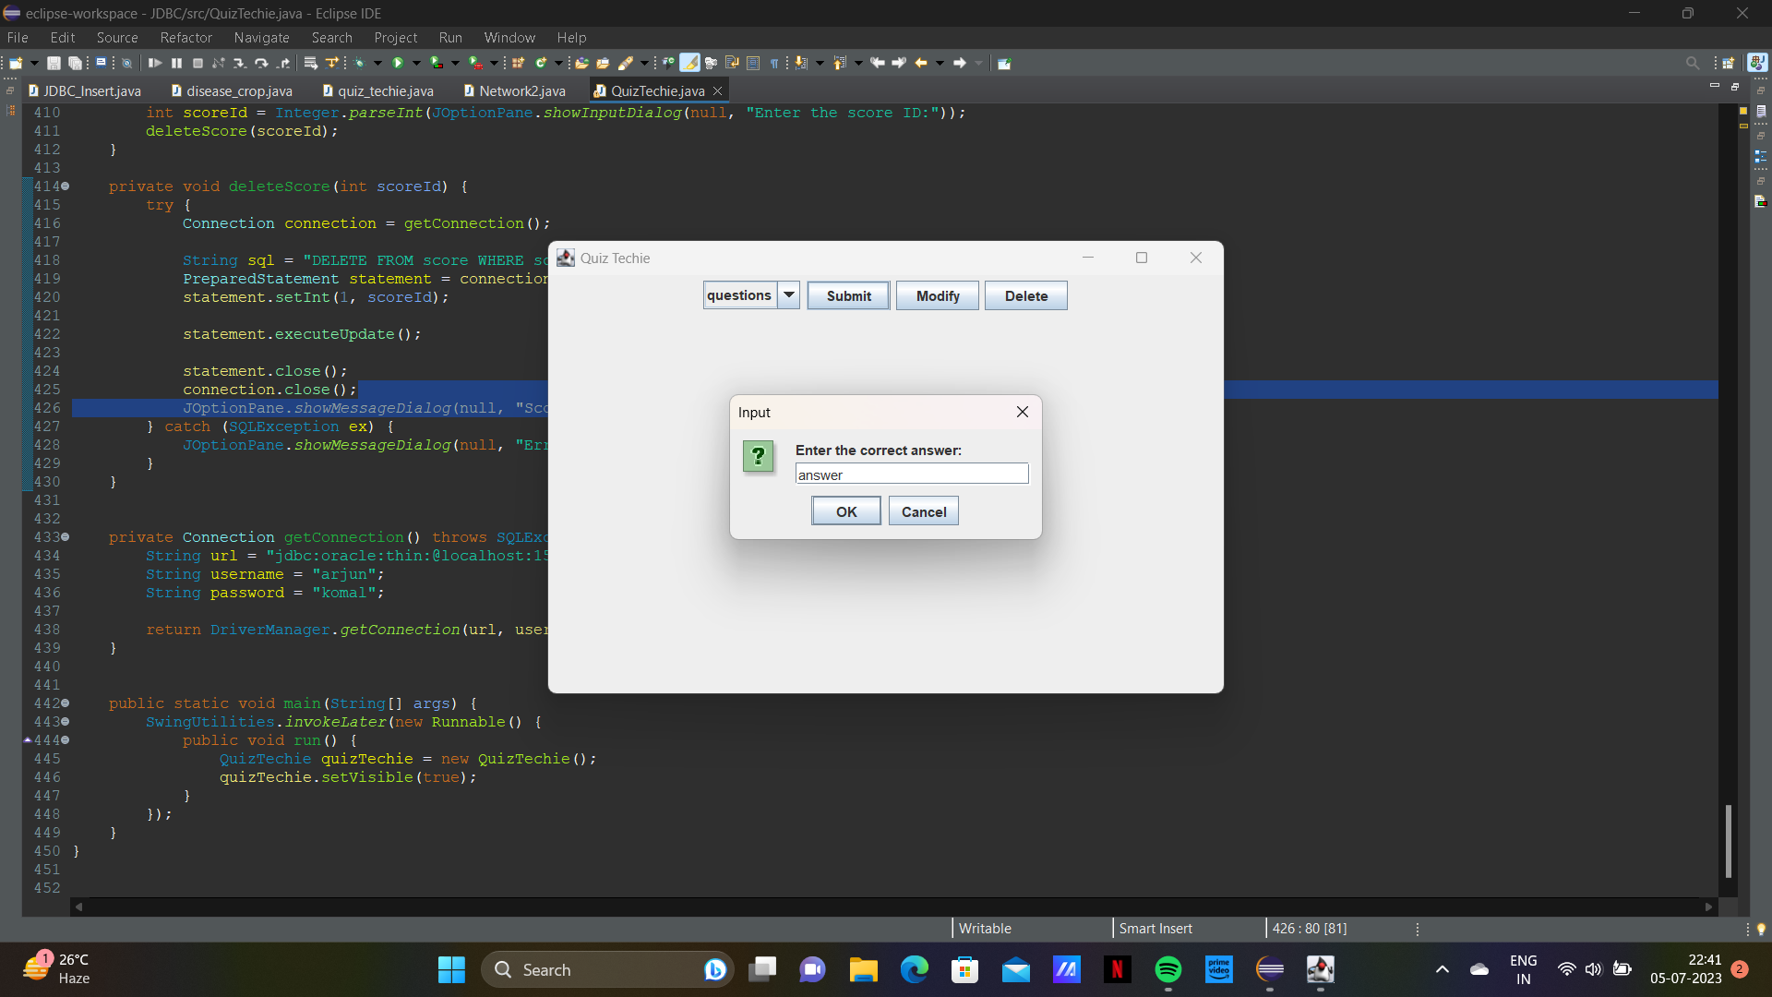

**10.ENTER SCORE ID**

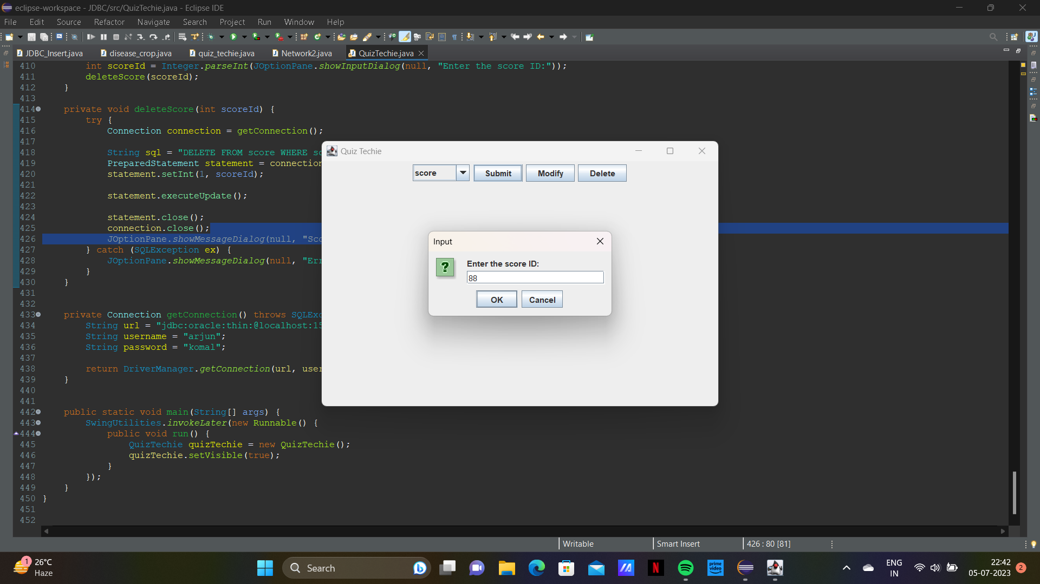

**11. ENTER TOTAL SCORE**

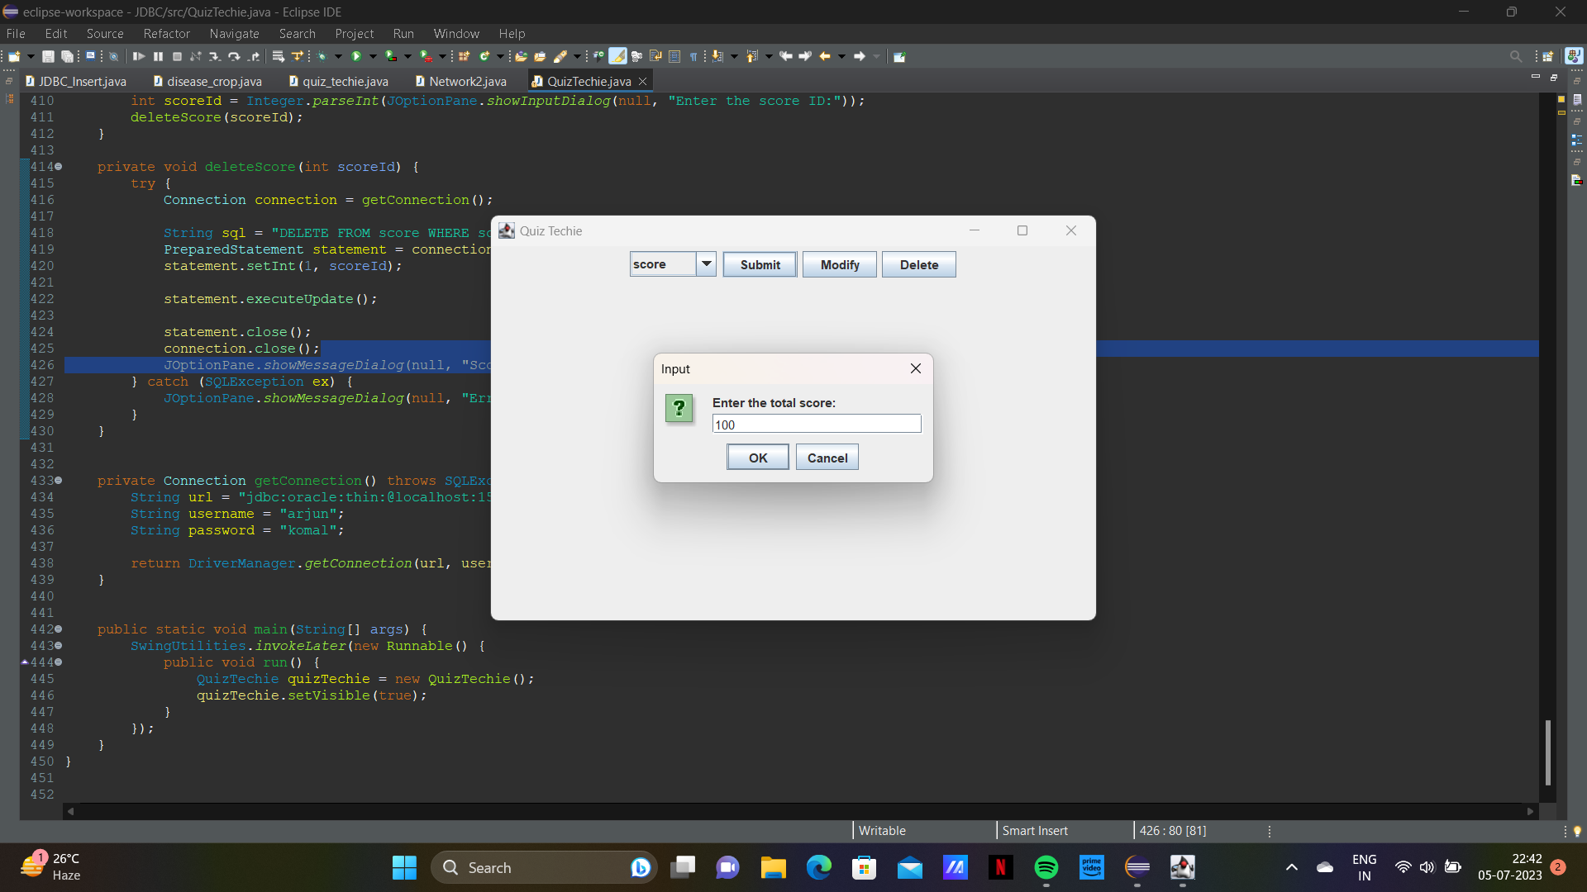

**12. INTEGRITY CONSTRAINT**

 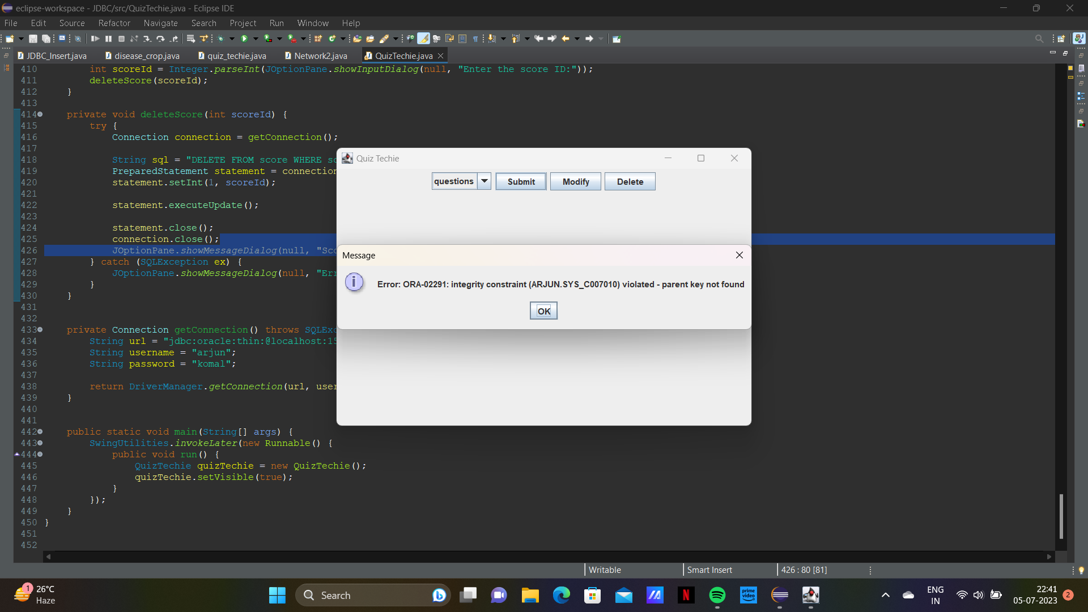

### RESULTS

I have successfully completed the mini-project ***“TECHIE QUIZ FOR C AND PYTHON”*** .

### DISCUSSION AND FUTURE WORK

This project contains the basic interaction of giving information by students for suggesting the correct career choice. It has a very basic user interface. Future scope would be to make the UI more appealing by using graphics. more feature would be to allow student-users to upload their resumes and official One documents required so that we can suggest more accurate career choices. We can also think of including a feedback system to allow the users to leave their valuable feedback after using this app. Making this feedback to be publicly viewable, would attract many more users to use this app.

### REFERENCES

* https://docs.oracle.com/javase/7/docs/api/
* [https://www.javatpoint.com/java-swing](http://www.javatpoint.com/java-swing)
* https://stackoverflow.com/